CSS GENDER STUDIES
T7KB
The Knowledge Base
Topic 7 · Gender-Based Violence and the Three Case Studies — taught from zero
WHAT THIS DOCUMENT GIVES YOU
◆ Syllabus Heads VIII and IX taught from zero in simple English — what gender-based violence is, how big the problem is, and how it is defined in international and Pakistani law
◆ The theories of violence against women — social learning, resources, feminist and power-and-control theory, the cycle of violence, the ecological model and Galtung's direct, structural and cultural violence
◆ The root causes of violence in Pakistan and how they intersect
◆ Every form and site of violence against women in Pakistan, with honour killing in depth and the latest data
◆ The laws and government initiatives, the Punjab Protection of Women against Violence Act 2016 section by section, consequences and workable strategies
◆ Masculinity studies and violence
◆ The three case studies — Mukhtaran Mai, Malala Yousafzai and Sharmeen Obaid-Chinoy
◆ Today's debates, the record and five likely questions
◆ About 125 MCQ-style one-liners, every past MCQ on the topic, and a detailed revision sheet
Federal Public Service Commission · CSS Competitive Examination · Optional paper, 100 marks
Written for CE-2027 onwards · Record: CE-2016 to CE-2026 · Facts current to September 2026

Contents
HOW TO BUILD THE CONTENTS
The contents list below fills itself in. When Word asks "This document contains fields that may refer to other files. Update the fields?", click Yes.
If it does not ask: right-click the grey contents area → Update Field → Update entire table → OK. On a Mac, Control-click the same area. Or press Ctrl + A, then F9 (Windows), to update every field at once. Repeat after any edit, before you export to PDF.

Right-click here and choose Update Field to build the contents.

How to Use This Document

What this topic covers
Topic 7 joins two syllabus heads. Head VIII — Gender-Based Violence names: defining gender-based violence; theories of violence against women; structural and direct forms of violence; forms of violence against women in Pakistan (honour killing, rape, domestic violence, acid attacks, harassment and others); and laws, policies and strategies to combat it. Head IX — Case Studies names three Pakistani women: Mukhtaran Mai, Malala Yousafzai and Sharmeen Obaid-Chinoy. This document teaches every line, and adds the newest one the examiner has used: masculinity studies and violence (2026).
In the descriptive paper Topic 7 has had 10.5 visits: nine full questions and three short notes. Forms and strategies dominate — 2016, 2017 and 2023 asked almost the same question — and theory follows (power and control 2020; root causes 2025). The Punjab Protection of Women against Violence Act 2016 was named in 2024. Each case study has been asked: Mukhtaran Mai (2019), Sharmeen Obaid-Chinoy (2020) and Malala (2025). The topic also supplies 12 of the 140 MCQs — violence as learned behaviour (2023), 1 in 3 women (2024), socially constructed violence (2024), the 2016 honour-killing law (2026), Malala's birth year (1997), Mukhtaran Mai's region (South Punjab).
IN SIMPLE WORDS
Gender-based violence is harm done to a person because of their gender — most often by men against women, because society gives men power over women and treats women's bodies, choices and "honour" as men's business. It includes beating, rape, acid attacks, honour killings and harassment, but also threats, control and denying a woman money or freedom. It happens at home, at work, in the street, online and even in custody.

How this document is built
1. Part Zero gives you the words of the topic, the scale of the problem and the map of Topic 7.
2. Part One has nine chapters on gender-based violence: definitions (1); theories (2); power and control, and structural and direct violence (3); root causes and how they intersect (4); forms and sites in Pakistan (5); honour killing (6); laws, the Punjab Act of 2016 and government initiatives (7); consequences and strategies (8); and masculinities (9).
3. Part One-B has the three case studies: Mukhtaran Mai (10), Malala Yousafzai (11) and Sharmeen Obaid-Chinoy (12).
4. Part Two sets out today's debates.
5. Part Three lists every past question, what the record shows, and five likely questions.
6. Part Four is a bank of about 125 one-liners, followed by every past MCQ on the topic.
7. Part Five is the revision sheet.

Part Zero — The ABC of Topic 7

0.1 The words of this topic
Table 1 · The key terms of Topic 7 (★ = you must be able to define it in one sentence).
Term | Simple meaning, with an example
Gender-based violence (GBV) ★ | Violence directed at a person because of their sex or gender, or that affects one sex disproportionately (MCQ 2025).
Violence against women (VAW) ★ | Any act of gender-based violence that results in physical, sexual or psychological harm to women, including threats and coercion (DEVAW 1993).
Domestic violence ★ | Violence by a family member or intimate partner in the home — beating, sexual abuse, threats, control, denial of money.
Intimate partner violence | Violence by a husband, former husband or partner.
Honour killing ★ | Killing of a woman (sometimes a man) by relatives who claim she brought dishonour on the family — karo-kari, siyahkari, tor tora.
Femicide | The intentional killing of women and girls because they are women.
Acid attack | Throwing acid to disfigure, usually the face; punished under the Acid Control and Acid Crime Prevention Act 2011.
Sexual harassment ★ | Unwelcome sexual advances, requests or conduct; at work it is covered by the 2010 Act.
Rape | Sexual intercourse without consent; in the Penal Code since the 2006 Act.
Custom-based violence | Vani or swara (girls given in settlement), marriage to the Qur'an, forced marriage, denial of inheritance — made crimes by the 2011 Act.
Cyber violence | Online harassment, blackmail, stalking and image-based abuse; covered by PECA 2016.
Structural violence ★ | Harm built into social structures — poverty, unequal laws, denial of education — with no single person "hitting" (Galtung 1969).
Direct violence ★ | Visible, physical or verbal violence by a person against another — beating, rape, murder.
Cultural violence | Beliefs and symbols that make direct and structural violence seem normal or right (Galtung 1990).
Power and control ★ | The idea that abusers use violence to gain and keep control over a partner (Duluth wheel, 1981).
Cycle of violence | Tension building → explosion → reconciliation ("honeymoon") → calm (Lenore Walker 1979).
Coercive control | A pattern of domination through isolation, intimidation, surveillance and degradation (Evan Stark 2007).
Social learning theory ★ | Violence is learned by watching and copying others (MCQs 2023, 2024).
Ecological model | Violence explained at four levels — individual, relationship, community, society (Lori Heise 1998).
Hegemonic masculinity ★ | The dominant ideal of manhood — tough, controlling, the protector of "honour" (Connell).
Protection order | A court order directing an abuser to stay away from, and not contact, a woman (Punjab Act 2016, s. 7).
Impunity | Escape from punishment — e.g. honour killers pardoned by their own family under the old law.

0.2 The scale of the problem
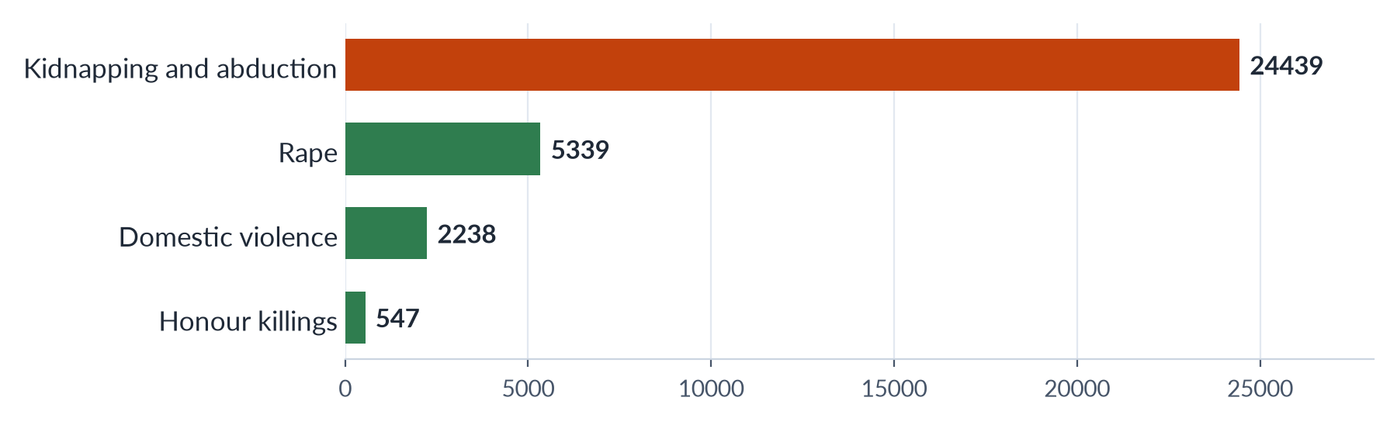
Figure 1 · Violence against women in Pakistan, 2024 — cases reported (SSDO).
✦ DATA
The numbers to remember
• World: about 1 in 3 women have experienced physical or sexual violence (WHO, 2021; MCQ 2024). In 2023, about 85,000 women and girls were killed intentionally, 51,100 of them by partners or family members — one every 10 minutes (UNODC and UN Women).
• Pakistan: 28% of ever-married women have experienced physical violence since age 15, and 34% spousal physical, sexual or emotional violence; 56% of those who suffered violence never sought help (PDHS 2017–18).
• Reported cases, 2024: 32,617 GBV cases, with conviction rates of only about 0.5% for rape and honour killing (SSDO); at least 405 honour killings (HRCP).

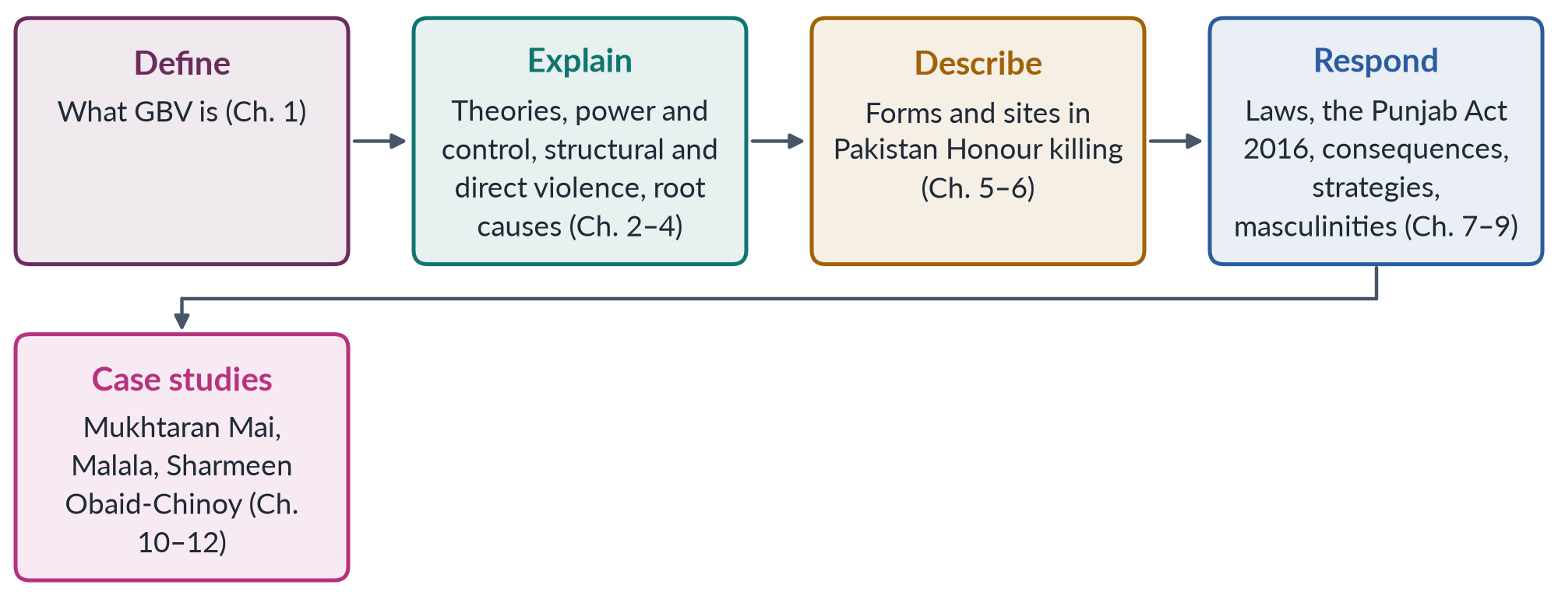
Figure 2 · The map of Topic 7.
EXAMINER'S EYE · HOW THE EXAMINER USES THIS TOPIC
Every full question on violence has two or three parts: "define… forms… strategies" (2016, 2017, 2023); "what is GBV… forms under the Punjab Act… consequences" (2024); "root causes… how they intersect" (2025). Learn a five-part frame for every answer: (1) a precise definition (DEVAW 1993); (2) data (PDHS, SSDO, HRCP); (3) theory (power and control, Galtung, ecological model); (4) forms, causes or laws as asked; (5) strategies organised as prevention, protection, prosecution, provision and partnership. For the case studies, always give the background, the event, the legal and social response and an evaluation.

Part One — Gender-Based Violence

Chapter 1 · Defining Gender-Based Violence
Three questions began with a definition: "Define gender-based violence" (2023), "What is gender-based violence?" (2024), and "What are the different forms of gender-based violence…?" (2017). A 2025 MCQ asked what GBV is (violence based on sex or gender), and a 2024 MCQ asked how many women worldwide face it (1 in 3).

1.1 Violence, gender and gender-based violence
Violence is the intentional use of physical force or power, threatened or actual, that results in — or is likely to result in — injury, death, psychological harm, maldevelopment or deprivation (WHO, 2002). Notice that the WHO definition includes power, not only force, and deprivation, not only injury.
Gender refers to the roles, behaviour and attributes a society considers appropriate for women and men (Topic 1). Gender-based violence joins the two: it is violence rooted in gender inequality and in the norms that give men power over women.
✦ DEFINITION
Gender-based violence · UNHCR and UN Women
"Harmful acts directed at an individual or a group of individuals based on their gender. It is rooted in gender inequality, the abuse of power and harmful norms." It includes physical, sexual, psychological and economic harm, and threats of such acts, in public or private life.

GBV can be directed at men and boys too — for example, sexual violence against men in conflict or violence against gay or transgender people. But because it grows out of unequal power, women and girls are its main victims. That is why the terms GBV and violence against women (VAW) are often used together.

1.2 The landmark definition — DEVAW 1993
✦ LAW & POLICY
UN Declaration on the Elimination of Violence against Women (1993) · Articles 1 and 2
Article 1: "violence against women" means "any act of gender-based violence that results in, or is likely to result in, physical, sexual or psychological harm or suffering to women, including threats of such acts, coercion or arbitrary deprivation of liberty, whether occurring in public or in private life." Article 2 lists three sites: (a) violence in the family (battering, sexual abuse of girls, dowry violence, marital rape, female genital mutilation and other traditional practices); (b) violence in the community (rape, sexual harassment at work and in schools, trafficking, forced prostitution); and (c) violence perpetrated or condoned by the State.
➜ The definition every examiner expects. Note its four parts: harm (physical, sexual, psychological), threats and coercion, deprivation of liberty, and public or private life.

The General Assembly adopted DEVAW on 20 December 1993, after the Vienna World Conference on Human Rights (1993) declared that "the human rights of women… are an inalienable, integral and indivisible part of universal human rights". In 1999 the UN designated 25 November as the International Day for the Elimination of Violence against Women, which begins the global "16 Days of Activism" ending on Human Rights Day, 10 December.

1.3 Other international milestones
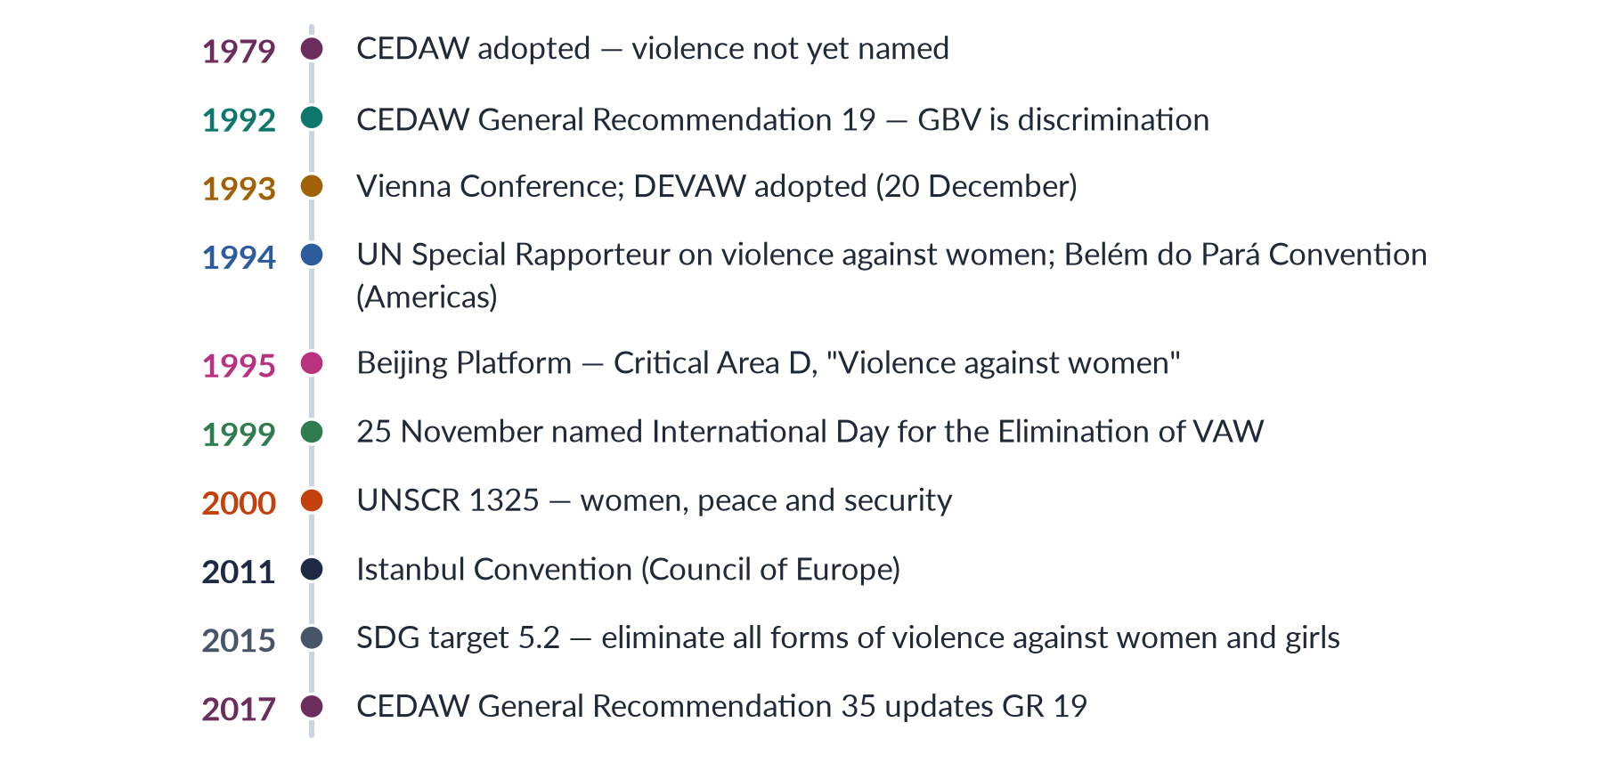
Figure 3 · How violence against women became an international human-rights issue.
- CEDAW (1979) did not mention violence directly. Its committee filled the gap with General Recommendation 19 (1992), which declared that gender-based violence is a form of discrimination that seriously inhibits women's ability to enjoy rights and freedoms. General Recommendation 35 (2017) updated it, recognising that the prohibition of GBV has become a principle of customary international law.
- The Beijing Platform for Action (1995) made "violence against women" one of its twelve critical areas (Area D).
- The Council of Europe's Istanbul Convention (2011) is the most detailed binding treaty, requiring prevention, protection, prosecution and integrated policies — the "four Ps".
- SDG target 5.2 (2015) calls for the elimination of all forms of violence against all women and girls, and 5.3 for the elimination of child marriage and other harmful practices.

1.4 Pakistan's legal definition
Pakistan has no single national definition of GBV, but the Punjab Protection of Women against Violence Act 2016 gives the most complete one. Section 2(r) defines violence as "any offence committed against the human body of the aggrieved person including abetment of an offence, domestic violence, sexual violence, psychological abuse, economic abuse, stalking or a cybercrime". It also explains economic abuse (denial of food, clothing and shelter, or taking away a woman's income) and psychological violence (deterioration such as depression or suicide attempts resulting from oppressive behaviour or restricted movement). Chapter 7 studies the Act in detail.

1.5 Types of GBV — four ways to classify
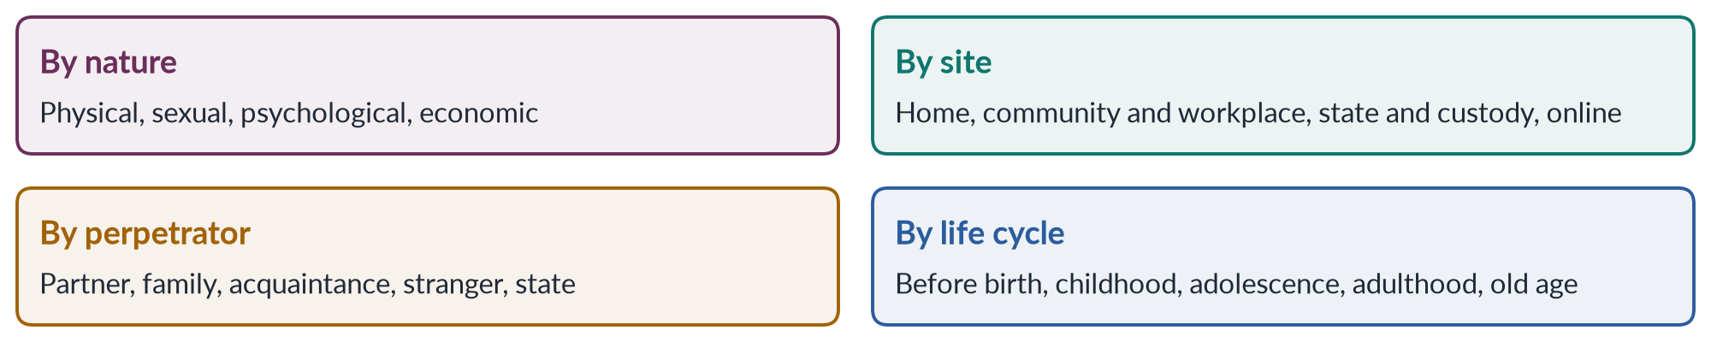
Figure 4 · Four ways to classify gender-based violence.

(1) By nature
1. Physical: slapping, beating, burning, acid attacks, murder.
2. Sexual: rape (including marital rape), sexual assault, harassment, forced marriage, trafficking.
3. Psychological or emotional: threats, insults, humiliation, isolation, controlling behaviour.
4. Economic: denial of money, food or inheritance; taking a woman's earnings; preventing her from working.

(2) By site
Home (domestic violence), community and workplace (harassment, rape, honour killings ordered by jirgas), the state (custodial violence, discriminatory laws, police inaction) and online (cyber-harassment). Question 2016 asked for the "sites" of violence — use this classification.

(3) By life cycle
WHO and UNICEF describe violence across a woman's life:
Table 2 · Violence across the life cycle of a woman.
Stage | Forms of violence
Before birth | Sex-selective abortion; neglect of pregnant women carrying girls
Infancy and childhood | Neglect of girls, less food and health care; child sexual abuse; child labour
Adolescence | Child and forced marriage; vani and swara; harassment on the way to school; trafficking
Reproductive years | Domestic violence; marital rape; honour killing; acid attacks; dowry violence; harassment at work
Old age | Neglect; denial of inheritance; abuse of widows

1.6 The continuum of violence
The British sociologist Liz Kelly, in Surviving Sexual Violence (1988), argued that violence against women is a continuum: everyday harassment, threats, coercion and rape are connected, not separate events. They share a common cause — men's power — and a common effect — women's fear and restricted freedom. The continuum explains why "small" acts such as street harassment matter: they make women limit their movements, just as the threat of rape does.
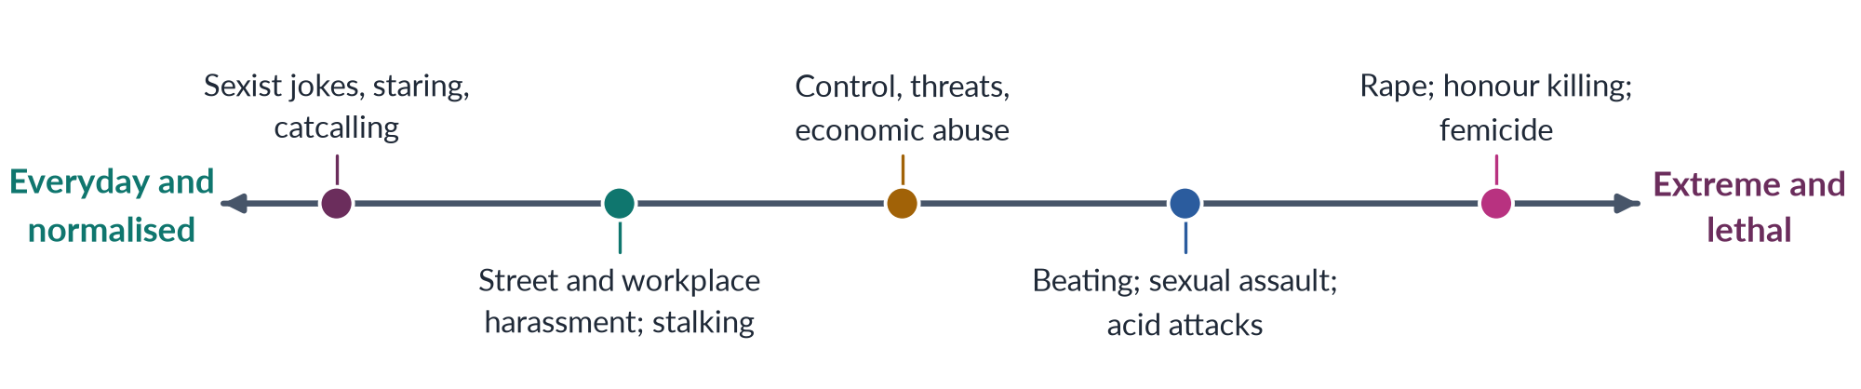
Figure 5 · Kelly's continuum of violence — from everyday to extreme, all connected.

1.7 Why GBV is a human-rights, health and development issue
- Human rights: it violates the rights to life, security, dignity, equality and freedom from torture (Pakistan's Articles 9, 14 and 25).
- Public health: the WHO calls violence against women a "global public health problem of epidemic proportions" — causing injury, depression, unwanted pregnancy, HIV and death.
- Development: it keeps girls out of school and women out of work, and costs economies through health care, lost output and justice spending.
- Security and democracy: fear of violence keeps women out of public life, including politics (Topic 6).
BALANCED VIEW · GBV OR VAW — WHICH TERM SHOULD YOU USE?
• "Violence against women" keeps the focus on women, who are the overwhelming majority of victims, and on men's power.
• "Gender-based violence" is broader — it includes violence against men and boys and against sexual minorities when it is driven by gender norms, and shows that the cause is gender, not biology.
➜ Line to take: define GBV (as the questions ask), then explain that it falls mainly on women because it is rooted in unequal gender power; use DEVAW for the definition of VAW.

EXAMINER'S EYE · THE MODEL INTRODUCTION FOR 2023 AND 2024
"Gender-based violence is harm directed at a person because of their gender, rooted in unequal power between women and men. The UN Declaration of 1993 defines violence against women as any act of gender-based violence that results in physical, sexual or psychological harm, including threats, coercion or deprivation of liberty, in public or private life. Worldwide about 1 in 3 women experience it; in Pakistan 28% of ever-married women have suffered physical violence (PDHS 2017–18)."

Chapter 2 · Theories of Violence against Women
The syllabus names "theories of violence against women". The 2020 question asked about the "power-and-control relationship", the 2025 question about root causes, and the 2026 note about masculinity studies. MCQs asked whether domestic violence is a learned behaviour (2023) and whether, according to social learning theory, violence is socially constructed (2024).

2.1 Why theories matter
A theory answers the question why. Why do some men beat, rape or kill women? Why is violence more common in some families, communities and countries? Each theory points to a different cause — the individual, the family, the culture or the structure of society — and so to a different solution. A strong answer names several theories and shows that the most convincing explanations combine them.
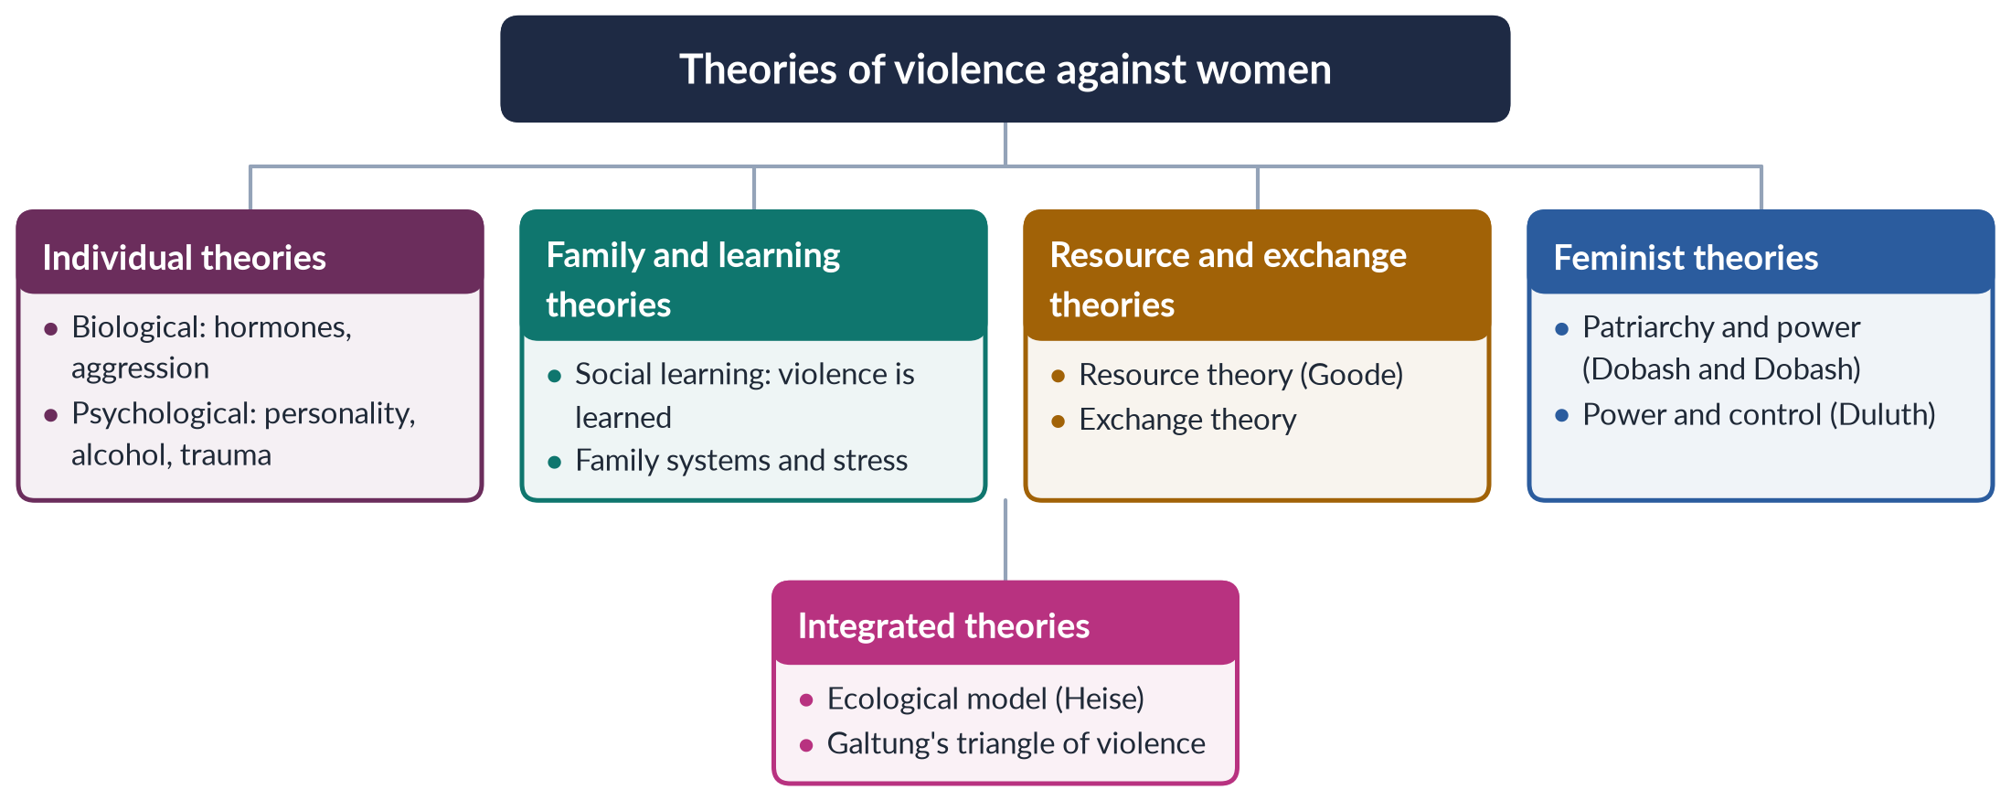
Figure 6 · The main families of theories of violence against women.

2.2 Individual theories — biological and psychological

(1) Biological explanations
Some explanations link male violence to testosterone, brain structure or evolutionary pressures — for example, the claim that men evolved to guard their mates through jealousy and aggression.
Critique: biology cannot explain why rates of violence differ so much between countries and over time, why most men are not violent, or why violent men usually control their violence at work and target only their wives. Biological theories risk excusing violence as "natural".

(2) Psychological explanations
These focus on the abuser's personality — anger problems, low self-esteem, mental illness, jealousy — or on alcohol and drugs, or on childhood trauma.
Critique: most abusers do not have a mental illness; violence is often planned and selective, not a loss of control; alcohol is a trigger, not a cause (many men drink without beating anyone, and in Pakistan most violence occurs without alcohol). Psychological theories also tend to blame victims — for example, the old idea that some women "provoke" violence.

2.3 Social learning theory
✦ THINKER
Albert Bandura · *Aggression: A Social Learning Analysis* (1973)
Bandura's "Bobo doll" experiments (1961) showed that children who watched adults hit a doll copied the behaviour. People learn violence by observing others, especially parents and role models, and by seeing it rewarded or go unpunished.
➜ The basis of the MCQ answers that domestic violence is "learned behaviour" (2023) and "socially constructed" (2024).

Applied to violence against women, social learning theory says:
1. Boys who see their fathers beat their mothers are more likely to beat their own wives; girls who see it are more likely to accept it — the intergenerational transmission of violence.
2. Violence is learned when it works — when it gets the abuser what he wants and goes unpunished.
3. Media, films and songs that glorify men's control over women teach the same lesson.
Strengths: explains the family patterns found in surveys; offers solutions through education, positive role models and punishment.
Critique: many children from violent homes do not become violent; the theory does not explain why it is men who learn to be violent against women — for that we need gender and power.
PAKISTAN ANGLE · LEARNED ACCEPTANCE IN PAKISTAN
In the PDHS 2017–18, a large share of women and men agreed that a husband is justified in beating his wife for at least one reason — such as going out without telling him, neglecting the children or arguing with him. This acceptance is itself learned, and it helps explain why 56% of women who suffered violence never sought help.

2.4 Resource and exchange theories
The American sociologist William Goode (1971) argued that force is one resource a person can use to get his way. Men who lack other resources — money, education, status — are more likely to resort to violence to maintain authority in the family. Exchange theory adds that people use violence when the rewards exceed the costs — when there is little risk of punishment, divorce or loss of status.
Applied: violence may rise when a man loses his job or his wife earns more, threatening his role as provider; and it persists where the costs to the abuser are low — no police action, no social sanction, a family that forgives.
Critique: wealthy, educated men also abuse; the theory explains the conditions for violence but not why men feel entitled to authority in the first place.

2.5 Feminist theories — patriarchy and power
✦ THINKER
R. Emerson Dobash and Russell Dobash · *Violence Against Wives: A Case Against the Patriarchy* (1979)
Studying Scottish court and police records and interviewing women, the Dobashes found that wife-beating was not random or pathological but an expression of men's sense of authority and entitlement over wives — supported by law, religion, custom and institutions that long accepted a husband's "right" to "chastise" his wife.
➜ The classic statement of the feminist theory of domestic violence.

Feminist theory makes four claims:
1. Patriarchy is the root cause. Violence against women is a product of a social system in which men hold power over women — in the family, economy, law and culture.
2. Violence is functional. It keeps women subordinate, controlling their movement, sexuality, labour and choices.
3. The personal is political. "Private" violence in the home is a public issue of power and rights.
4. Institutions are complicit. Police, courts and communities that ignore or excuse violence sustain it.
Susan Brownmiller, in Against Our Will (1975), argued that rape is "a conscious process of intimidation by which all men keep all women in a state of fear" — a controversial but influential claim that rape is about power, not sex.
Strengths: explains why most victims are women and most perpetrators men; explains the role of honour, control and entitlement; inspired the laws, shelters and helplines of the past fifty years.
Critique: may overlook violence by women and in same-sex relationships; can treat all men as potential abusers; may underplay class, race and individual factors. Intersectional feminists (Crenshaw, 1991, "Mapping the Margins") showed that poor women and women of colour face violence shaped by race and class as well as gender.

2.6 Power and control theory
The most influential feminist model in practice is the Power and Control Wheel, developed in Duluth, Minnesota, by the Domestic Abuse Intervention Project (1981) from the accounts of battered women. It shows that physical and sexual violence are the outer rim of a wheel whose spokes are tactics of control: intimidation, emotional abuse, isolation, minimising and blaming, using children, male privilege, economic abuse, and coercion and threats. Chapter 3 studies it in detail, with Lenore Walker's cycle of violence (1979) and Evan Stark's coercive control (2007).

2.7 Integrated theories

(1) The ecological model
✦ THINKER
Lori Heise · "Violence against women: an integrated, ecological framework" (1998)
Heise argued that no single factor explains violence. Instead, it results from factors interacting at four levels: the individual (e.g. witnessing violence as a child, alcohol), the relationship (male control of wealth and decisions, marital conflict), the community (poverty, isolation of women, peer groups that approve violence) and society (norms of male entitlement, acceptance of violence, rigid gender roles).
➜ Adopted by the WHO and used throughout this document — and the best framework for "root causes… how do they intersect" (2025).

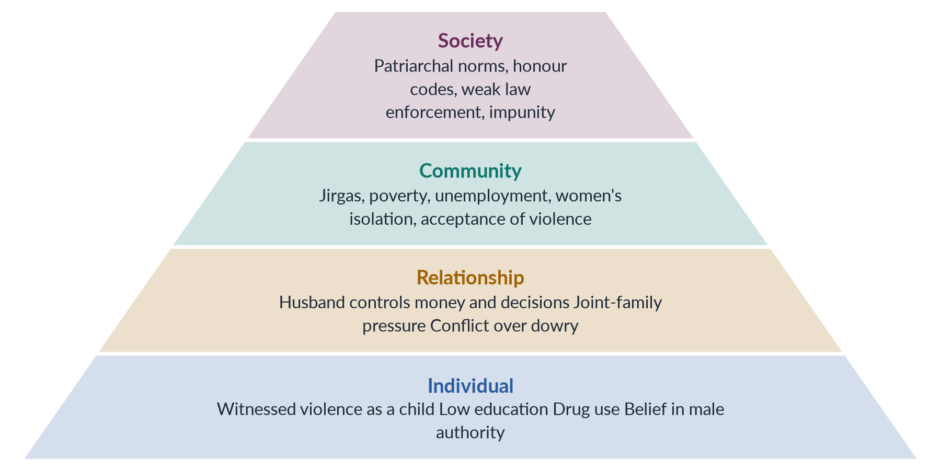
Figure 7 · The ecological model of violence against women (after Heise, 1998), applied to Pakistan.

(2) Galtung's triangle of violence
The Norwegian peace scholar Johan Galtung distinguished direct violence (visible, by a person), structural violence (built into social structures, 1969) and cultural violence (the beliefs that justify both, 1990). The 2019 question on "structural and direct forms of violence" draws on Galtung — see Chapter 3.

2.8 Comparing the theories
Table 3 · The theories of violence against women compared.
Theory | Main cause of violence | Strength | Weakness
Biological | Male hormones and evolution | Notes sex differences in aggression | Ignores culture; excuses violence
Psychological | Personality, alcohol, trauma | Explains some individual cases | Most abusers are not ill; blames victims
Social learning (Bandura) | Violence is learned and rewarded | Explains family patterns | Does not explain why men target women
Resource (Goode) | Force used when other resources fail | Explains stress and job loss | Rich men abuse too
Feminist (Dobash) | Patriarchy, male entitlement | Explains gender pattern and honour | May overlook other factors
Power and control (Duluth) | Abuser seeks control | Shows non-physical tactics | Focus on intimate partners
Ecological (Heise) | Interaction of four levels | Comprehensive; guides policy | Less precise about the main cause
Galtung | Direct, structural, cultural violence | Links visible violence to structures | Very broad

BALANCED VIEW · WHICH THEORY EXPLAINS VIOLENCE IN PAKISTAN BEST?
• Feminist and power-and-control theories best explain honour killings, acid attacks and domestic violence, which are about men controlling women's choices and bodies.
• Social learning explains how acceptance of violence passes from parents to children.
• Resource theory explains why unemployment and poverty raise tensions.
• The ecological model brings them together and shows where to act.
➜ Line to take: violence against women in Pakistan is best explained by an ecological, feminist approach: patriarchal norms and impunity at the top, community institutions such as jirgas in the middle, and learned behaviour and economic stress at the level of the family and individual.

EXAMINER'S EYE · USING THEORY IN ANY ANSWER
Even when a question asks only for "forms" or "strategies", add one paragraph of theory: "Feminist theory sees violence as a means of power and control; social learning theory shows it is learned; Heise's ecological model shows causes at four levels." Examiners reward the analytical frame.

Chapter 3 · Power and Control; Structural, Direct and Cultural Violence
"Comment on the power-and-control relationship in gender-based violence" (2020). "Explain the structural and direct forms of violence against women in Pakistani society by highlighting the case study of Mukhtaran Mai" (2019). This chapter gives you the two frameworks those questions need.

3.1 Violence as a means of control
The central insight of feminist research is that much violence against women is instrumental: it is not simply an outburst of anger but a way of getting and keeping control — over a woman's movement, money, friendships, sexuality, marriage choices and even her thoughts. Physical violence may be rare in a relationship and still dominate it, because the threat of it shapes everything the woman does.
IN SIMPLE WORDS
Think of a man who beat his wife once, badly, two years ago. Since then he has not hit her — but she asks permission to visit her mother, hands him her salary and avoids "upsetting" him. The violence is still working. That is what "power and control" means.

3.2 The Duluth Power and Control Wheel
In 1981 the Domestic Abuse Intervention Project in Duluth, Minnesota (USA) — led by activists including Ellen Pence and Michael Paymar — began building a co-ordinated community response to domestic violence. From the accounts of women in support groups, they drew the Power and Control Wheel (published in the mid-1980s). It became the most widely used tool in the world for understanding domestic abuse.
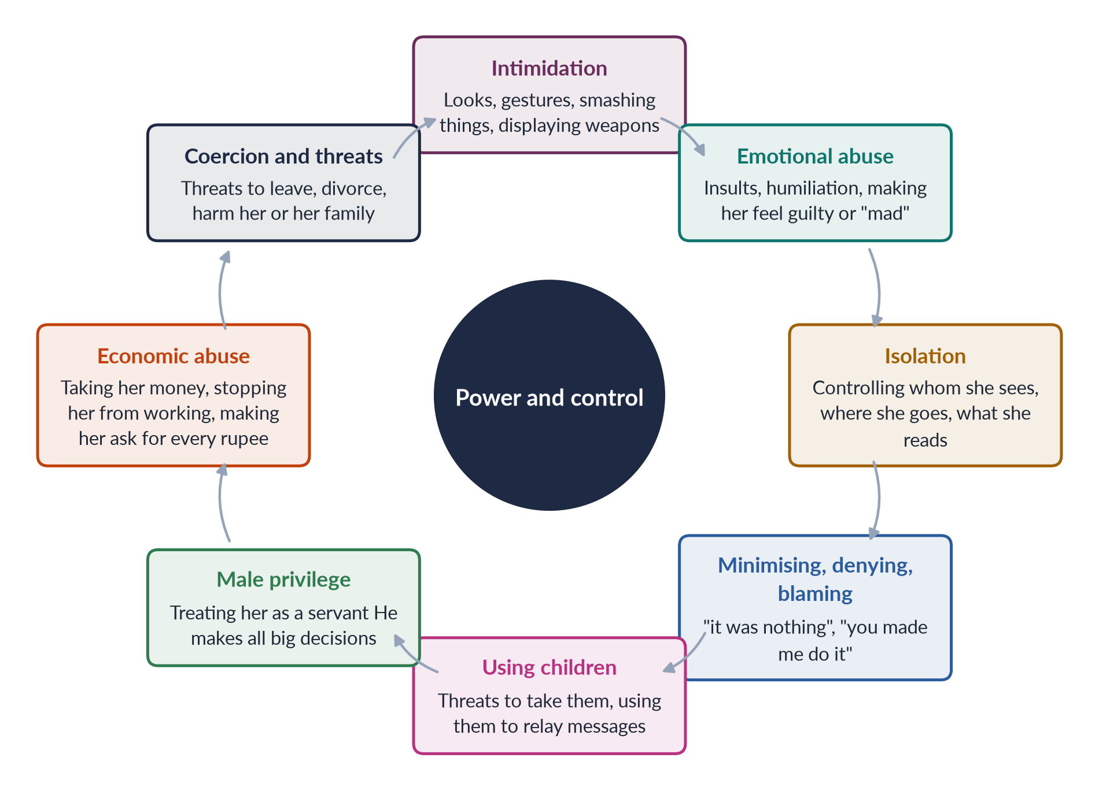
Figure 8 · The Duluth Power and Control Wheel — tactics around the hub, held together by violence.
The hub is power and control; the spokes are tactics of control; the rim is physical and sexual violence, which "holds the wheel together" — giving the other tactics their force.

Applying the wheel to Pakistan
Table 4 · The power and control tactics in Pakistani settings.
Tactic | Pakistani example
Intimidation | Threats of talaq (divorce) or of a second marriage; smashing household goods
Emotional abuse | Taunts about dowry, about failing to bear sons, about her family
Isolation | Forbidding visits to her parents; confiscating her phone; restricting her to the house (purdah used as control)
Minimising and blaming | "A husband has a right to discipline his wife"; family and elders blame the wife
Using children | Threats to take the children, or to deny custody, if she leaves
Male privilege | Husband or in-laws decide on her work, schooling, health care and contraception
Economic abuse | Taking her salary or dowry; denying her share of inheritance; forbidding paid work
Coercion and threats | Threats of acid attacks, honour killing or harm to her family

The Punjab Act 2016 recognises several of these tactics as "violence" — economic abuse, psychological abuse, stalking — not only physical assault.

3.3 The cycle of violence
✦ THINKER
Lenore Walker · *The Battered Woman* (1979)
Walker, an American psychologist, interviewed battered women and identified a recurring cycle of violence with three phases: (1) tension building — minor incidents, the woman tries to placate; (2) acute battering — the explosion; (3) loving contrition ("honeymoon") — apologies, gifts, promises to change. Then tension builds again, often faster.
➜ Explains why women stay: the "honeymoon" phase gives hope, while fear, dependence and shame trap them. Walker also described "learned helplessness" (later criticised as underestimating women's agency).

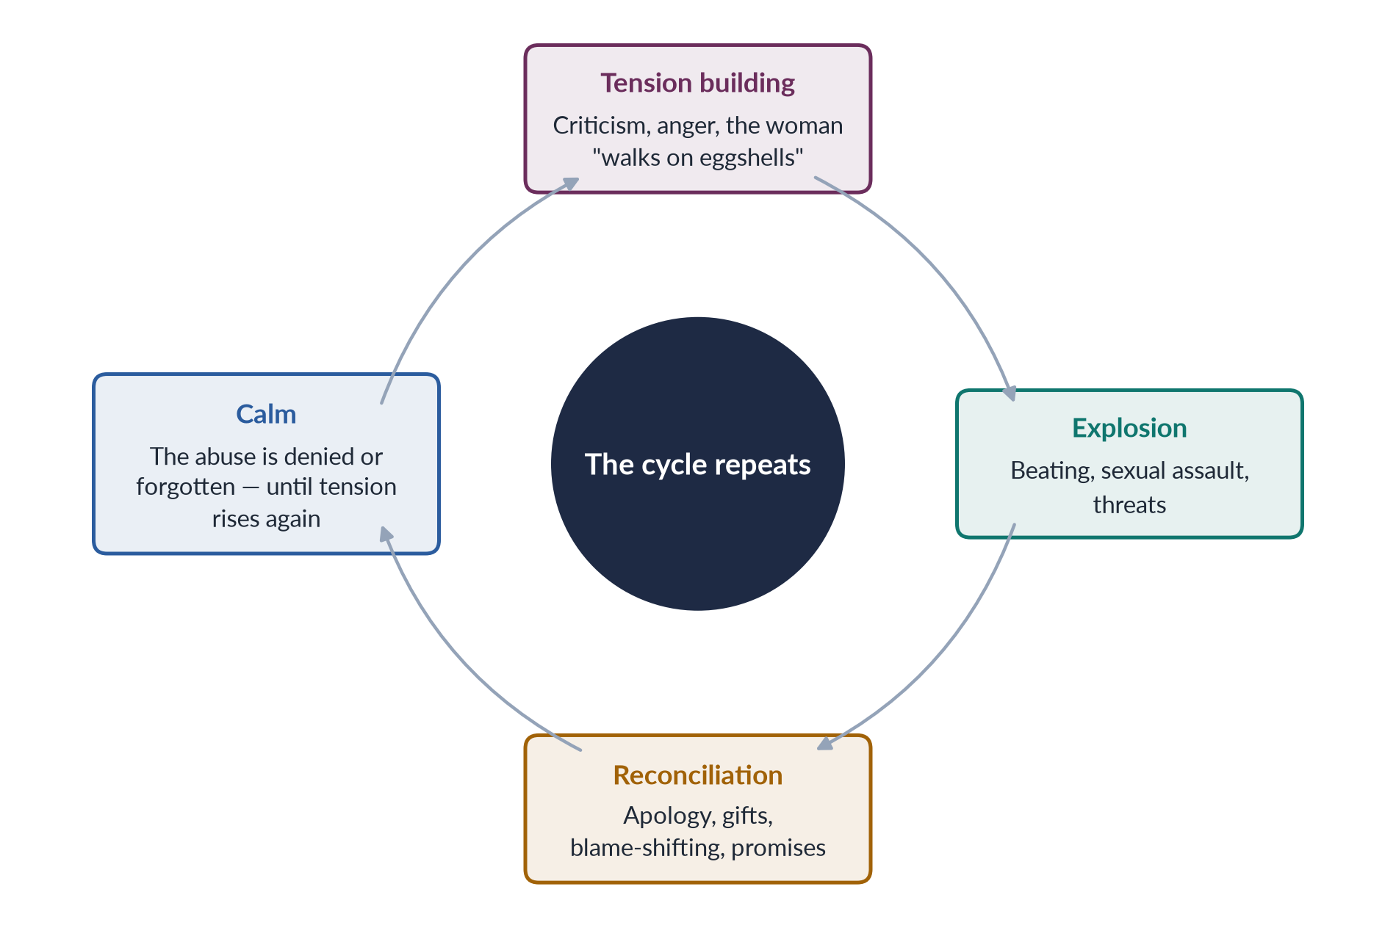
Figure 9 · Walker's cycle of violence (1979).

3.4 Coercive control and the typology of violence
The British sociologist Evan Stark, in Coercive Control (2007), argued that the core of domestic abuse is not individual assaults but a pattern of domination — isolation, intimidation, surveillance, degradation and the micro-regulation of daily life — that strips a woman of liberty, like a hostage. Several countries, including England and Wales (2015), have made coercive control a crime.
The American sociologist Michael Johnson (1995, 2008) distinguished intimate terrorism — violence used as part of a pattern of control, overwhelmingly by men — from situational couple violence — arguments that escalate, committed by both sexes and less likely to be severe. The distinction helps explain why some surveys find "equal" violence by men and women: they count situational conflicts, not control.

3.5 Commenting on the power-and-control relationship (2020)
BALANCED VIEW · HOW FAR DOES "POWER AND CONTROL" EXPLAIN GBV?
• Strengths: it explains why violence is selective (directed at wives, not bosses), patterned and gendered; it shows that non-physical abuse is real abuse; it fits honour killing, acid attacks and forced marriage, which punish women for exercising choice; it guides practice — the Duluth model of a co-ordinated community response and perpetrator programmes.
• Limits: it focuses on intimate partners and may miss stranger violence and state violence; it may underplay alcohol, mental illness or poverty; some perpetrator programmes based on it show mixed results; it can overlook situational couple violence.
➜ Line to take: power and control is the best single explanation of gender-based violence, especially in a patriarchal society like Pakistan, but it works best inside an ecological frame that adds structure, culture and individual risk factors.

3.6 Galtung's triangle — direct, structural and cultural violence
✦ THINKER
Johan Galtung · Norwegian founder of peace studies
In "Violence, Peace, and Peace Research" (1969), Galtung defined violence as present "when human beings are being influenced so that their actual somatic and mental realisations are below their potential realisations". He distinguished personal or direct violence (with an identifiable actor) from structural violence (built into the social structure, with no single actor — "social injustice"). In "Cultural Violence" (1990), he added a third type: the aspects of culture — religion, ideology, language, art — that legitimise direct and structural violence.
➜ The framework for the 2019 question on "structural and direct forms of violence".

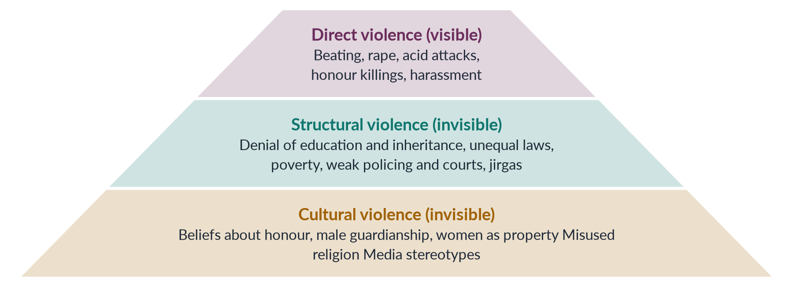
Figure 10 · Galtung's triangle applied to violence against women in Pakistan — visible violence rests on invisible foundations.

(1) Direct violence against women in Pakistan
Direct violence has a perpetrator and a victim: domestic beating, rape and gang rape, acid attacks, honour killings, stove burning, harassment at work and in the street, forced marriage and abduction. It is the visible "tip of the iceberg" — 32,617 reported GBV cases in 2024 (SSDO).

(2) Structural violence against women in Pakistan
Structural violence is harm caused by the way society is organised:
- Education: female literacy of about 53% (Census 2023) and millions of girls out of school.
- Health: maternal mortality of 186 per 100,000 live births (2019) — deaths that are mostly preventable.
- Economy: female labour-force participation of 24.4% and denial of inheritance.
- Law and justice: laws that once let honour killers be pardoned by their own families (the Qisas and Diyat law before 2016); the Hudood Ordinances (1979) under which rape victims risked prosecution for zina; slow courts and conviction rates around 0.5% for rape.
- Institutions: jirgas and panchayats that order vani, swara and punishments; police who refuse to register complaints.
Nobody "hits" anyone in these examples, yet they shorten women's lives and limit their potential — exactly Galtung's definition.

(3) Cultural violence
Cultural violence is the set of ideas that make the other two seem natural: the belief that a family's honour (izzat, ghairat) lives in its women's bodies; that a husband may "discipline" his wife; that daughters are "paraya dhan" (another's wealth); misinterpretations of religion; proverbs, songs and dramas that glorify male control or romanticise abuse.

3.7 How the three types reinforce one another
The three forms form a vicious circle. Cultural beliefs about honour justify structural arrangements (denying girls schooling, keeping women dependent), which make women vulnerable to direct violence (beating, forced marriage), which goes unpunished because of structural impunity and cultural acceptance.
✦ CASE
The Mukhtaran Mai case (2002) · all three types in one event
In Meerwala, a village panchayat dominated by a powerful clan ordered the gang rape of Mukhtaran Mai as "punishment" for her brother's alleged relationship with a woman of that clan (direct violence). The village council's power, the clan hierarchy, police reluctance and years of slow trials and acquittals reflect structural violence. The idea that a woman can be used to settle a family's "honour" debt is cultural violence.
➜ Chapter 10 tells the story in full.

EXAMINER'S EYE · THE MODEL STRUCTURE FOR 2019
1. Introduction: Galtung's definitions; the argument that direct violence rests on structural and cultural foundations. 2. Direct violence: forms and data. 3. Structural violence: education, health, economy, law, jirgas. 4. Cultural violence: honour, guardianship. 5. The Mukhtaran Mai case: facts, all three types, the legal journey. 6. How the types reinforce one another. 7. Responses. 8. Conclusion. Draw the triangle.

Chapter 4 · The Root Causes of Gender-Based Violence in Pakistan — and How They Intersect
"What are the root causes that lead to gender-based violence? How do these factors intersect and perpetuate violence against women in Pakistan?" (2025). Every "forms and strategies" question (2016, 2017, 2023) also needs a paragraph on causes — strategies only make sense if they attack causes.

4.1 Root causes and triggers
A root cause is a deep condition that makes violence likely across a society — patriarchy, gender inequality, impunity. A trigger or risk factor is a circumstance that sets off violence in a particular case — a quarrel over dowry, unemployment, drug use, a daughter's choice of husband. Triggers explain when violence happens; root causes explain why it is so common and so often directed at women. The UN and WHO identify gender inequality and harmful social norms as the root causes of GBV everywhere.
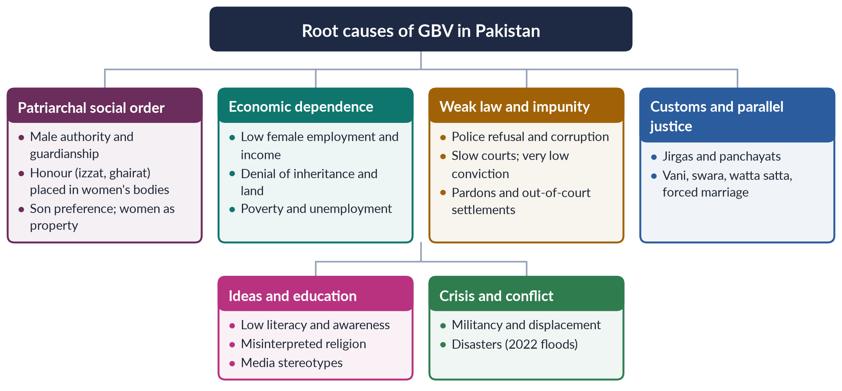
Figure 11 · The root causes of gender-based violence in Pakistan.

4.2 Root cause 1: the patriarchal social order
Pakistan's family and social structures are largely patriarchal: men are seen as heads of households, guardians (wali) and decision-makers, and women as dependants whose behaviour reflects on men.
1. Male authority: many believe a husband has the right to "discipline" his wife — in the PDHS 2017–18, large shares of women and men said wife-beating was justified in at least one situation.
2. Honour: a family's izzat is believed to depend on the chastity and obedience of its women. Any perceived breach — choosing a husband, seeking divorce, talking to a man, appearing on social media — can be punished, even by death (Chapter 6).
3. Son preference: sons carry the family name and support parents; daughters are "paraya dhan" (another's wealth). This leads to neglect of girls and to pressure and violence against women who do not bear sons.
4. Control of sexuality and marriage: forced marriage, watta satta (exchange marriage), and denial of a woman's right to marry by choice — despite the Supreme Court's ruling in the Saima Waheed case (2004) that an adult Muslim woman may marry without her guardian's consent.

4.3 Root cause 2: economic dependence and poverty
- Female labour-force participation is only 24.4% (LFS 2024–25); most working women are unpaid or informal.
- Women rarely own land or property and are often denied inheritance, despite Islamic law and the Enforcement of Women's Property Rights Act 2020.
- Economic dependence makes it hard for a woman to leave an abusive home: where would she live, and how would she support her children?
- Poverty and unemployment increase stress, conflict over money and dowry demands — triggers for violence, as resource theory predicts.

4.4 Root cause 3: weak law enforcement and impunity
Perhaps the most powerful cause of continued violence in Pakistan is impunity — the near-certainty that perpetrators will not be punished.
✦ DATA
Conviction rates in GBV cases, 2024 · Sustainable Social Development Organization (SSDO)
Of 32,617 reported GBV cases, conviction rates were about 0.5% for rape, 0.5% for honour killings, 1.3% for domestic violence and 0.1% for kidnapping and abduction. In Punjab, 225 honour killings led to only two convictions; in Sindh, there were no convictions for rape or honour killing.

Why? Police refuse or delay registering First Information Reports (FIRs), especially in "family matters"; investigations are poor, with weak forensic evidence; victims and witnesses face pressure to withdraw; trials take years; and until 2016, honour killers could be pardoned by their own families under the Qisas and Diyat law. Even after the 2016 reform, settlements and hostile witnesses free many accused — as in the Qandeel Baloch case, where her brother's conviction (2019) was overturned in 2022 after the parents pardoned him.

4.5 Root cause 4: customs and parallel justice
In many rural areas, disputes are settled by jirgas (in Pashtun and Baloch areas) or panchayats (in Punjab and Sindh) — councils of male elders. They have ordered:
- Vani or swara — giving young girls in marriage to an enemy family to settle a dispute or a murder;
- Punishments for alleged immorality, including declaring women kari (black) and ordering their deaths;
- In the Mukhtaran Mai case (2002), a gang rape as "punishment".
The Supreme Court has declared jirgas that violate fundamental rights to be illegal, and the Prevention of Anti-Women Practices Act 2011 made vani, swara and forced marriage crimes. Yet such councils continue, because the formal justice system is distant, slow and expensive.

4.6 Root cause 5: ideas, education and media
- Low literacy (about 53% for women) means many women do not know their legal rights; many men have learned that violence is acceptable (social learning).
- Misinterpreted religion: some clerics and elders justify beating, child marriage or honour killing in the name of Islam, although mainstream scholars reject honour killing as murder and Islam forbids compulsion in marriage.
- Media: some television dramas romanticise controlling husbands or show abuse as normal; social media spreads harassment and can trigger "honour" violence against women who post online.

4.7 Root cause 6: crisis and conflict
Militancy in the north-west brought attacks on girls' schools and on women in public life (Malala, 2012); displacement exposes women to violence in camps; the 2022 floods disrupted protection systems and raised risks of early marriage and exploitation. Research worldwide shows violence against women rises during crises, including the COVID-19 lockdowns of 2020.

4.8 How the causes intersect
The 2025 question's key word is "intersect". The causes do not act separately; they reinforce one another in a cycle.
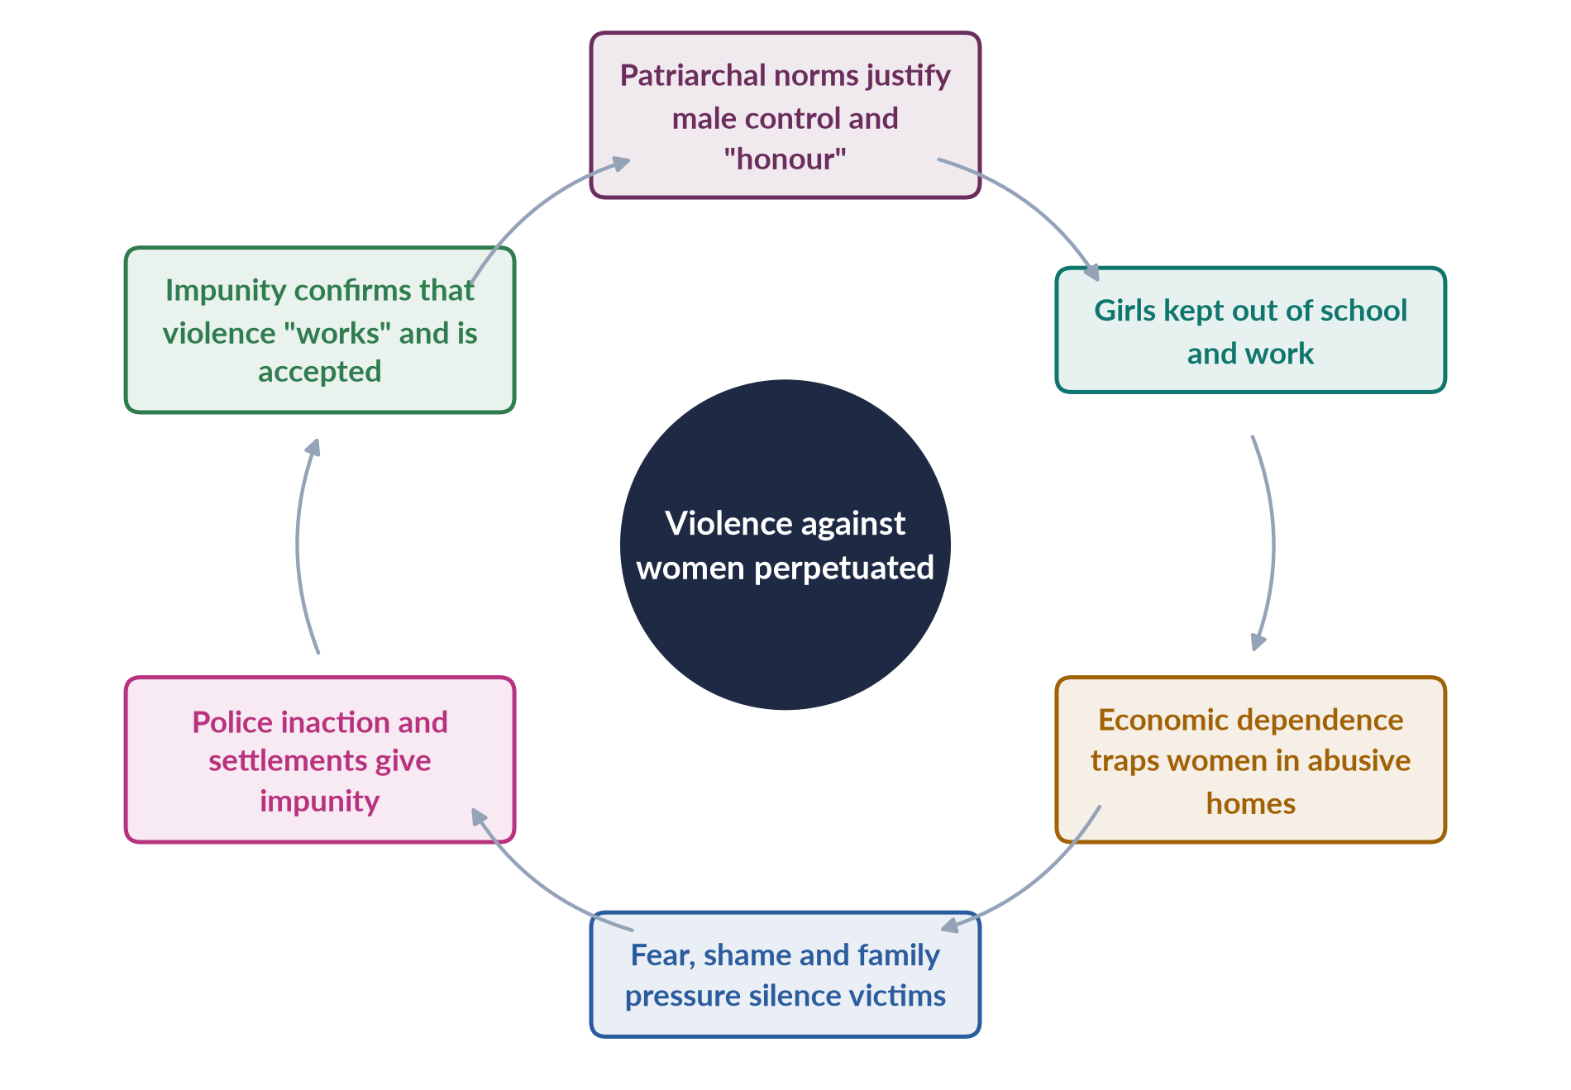
Figure 12 · How the root causes of GBV intersect and perpetuate violence in Pakistan.

(1) Intersection of causes
- Norms × economy: honour norms keep women at home; dependence keeps them silent.
- Economy × law: poor women cannot afford lawyers or travel to courts; abusers with money and connections buy settlements.
- Law × custom: where courts fail, jirgas fill the gap — and their judgements reflect patriarchal norms.
- Ideas × institutions: police officers who share the belief that "family matters" are private refuse to act.

(2) Intersection of identities
Using intersectionality (Crenshaw, 1989; Topic 5), violence falls hardest on women who face several disadvantages at once:
- Rural and poor women — far from police and courts, dependent on landlords and jirgas;
- Religious-minority women — reported abductions, forced conversions and marriages of Hindu and Christian girls, especially in Sindh and Punjab;
- Women with disabilities — more vulnerable to abuse and less able to report;
- Domestic workers — often girls, abused in employers' homes, as cases reported in the media have shown;
- Transgender persons (khawaja siras) — facing violence and murder, despite the Transgender Persons (Protection of Rights) Act 2018.

(3) Intersection across levels — the ecological model
Heise's ecological model (Chapter 2) shows how individual risk (a husband who witnessed violence as a child), relationship factors (male control of money), community factors (jirgas, poverty) and society-wide norms (honour, impunity) combine. Removing one level is not enough; strategies must work at all four.
Table 5 · The root causes mapped to the four ecological levels.
Level | Root causes and risk factors in Pakistan
Society | Patriarchal norms and honour codes; impunity; discriminatory laws (historically); misused religion
Community | Jirgas and panchayats; poverty and unemployment; isolation of women; acceptance of violence
Relationship | Husband's control of money and decisions; joint-family pressure; dowry disputes; forced or child marriage
Individual | Witnessing violence as a child; low education; drug use; belief in male authority

4.9 The line to take
BALANCED VIEW · IS CULTURE OR STRUCTURE THE MAIN CAUSE?
• Culture-first view: honour codes, patriarchal beliefs and customs are the root; change minds and violence will fall.
• Structure-first view: poverty, women's dependence and impunity are the root; give women income and enforce the law, and norms will follow.
➜ Line to take: the causes are mutually reinforcing — patriarchy is the root, but impunity and economic dependence are what allow it to keep producing violence. The most effective strategies attack all three at once: norms, economic independence and justice.

EXAMINER'S EYE · THE MODEL STRUCTURE FOR 2025
1. Introduction: GBV defined; root causes vs triggers; argument — causes are mutually reinforcing. 2. Patriarchy and honour. 3. Economic dependence and poverty. 4. Impunity — SSDO conviction data. 5. Customs and jirgas. 6. Ideas, education, media. 7. Crisis and conflict. 8. How causes intersect (cycle figure). 9. Intersecting identities (rural, minority, disabled, domestic workers, transgender). 10. Ecological levels. 11. Breaking the cycle. 12. Conclusion.

Chapter 5 · The Sites and Forms of Violence against Women in Pakistan
The most repeated question in Topic 7: "What are the sites and forms of violence against women in Pakistan…?" (2016); "What are the different forms of gender-based violence…?" (2017); "Explain various forms of violence against women in Pakistan…" (2023). The 2024 question asked for the forms named in the Punjab Act 2016. MCQs asked about sexual harassment (2023) and A Girl in the River (honour killing, 2019).

5.1 An overview
Violence against women in Pakistan takes many forms and occurs in every site of life. The data are incomplete — most violence is never reported — but the picture is consistent.
✦ DATA
The scale of violence in Pakistan
• Survey data: 28% of ever-married women aged 15–49 have experienced physical violence since age 15; 6% sexual violence; 34% spousal physical, sexual or emotional violence (PDHS 2017–18).
• Reported cases, 2024 (SSDO): 32,617 — kidnapping and abduction 24,439, rape 5,339, domestic violence 2,238, honour killings 547.
• HRCP, 2024: at least 405 honour killings; more than 3,300 reported cases of beatings; 14,425 cases of violence against women and girls documented.

5.2 The sites of violence (2016)
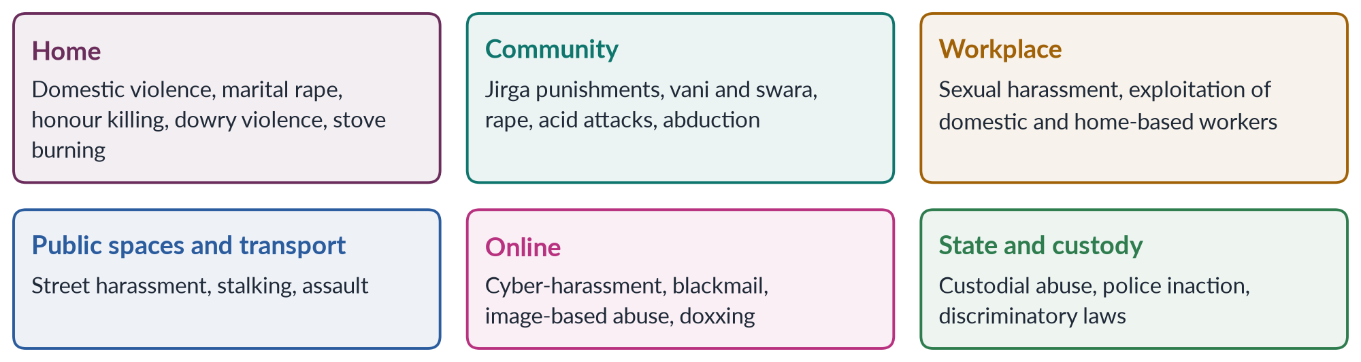
Figure 13 · The sites of violence against women in Pakistan.
1. The home — the most dangerous site. Violence by husbands, in-laws, fathers and brothers is the most common form, and honour killings are usually committed by family members.
2. The community — jirgas and panchayats, neighbours and local strongmen; rape, abduction and acid attacks often occur here.
3. The workplace — harassment of women in offices, factories, fields and hospitals; abuse of domestic workers, many of them children.
4. Public spaces and transport — street harassment and stalking that limit women's mobility.
5. Online — a growing site of harassment and blackmail.
6. The state — custodial violence, police refusal to register cases, and laws that once discriminated (the Hudood Ordinances, 1979).

5.3 Domestic violence
Domestic violence includes physical, sexual, psychological and economic abuse by a family member or partner. It is the most widespread form, but the least reported, because it is seen as a "private family matter".
- Forms: beating, burning, starvation, marital rape, threats of divorce or a second marriage, confinement, taking a woman's money, denying her food or medical care.
- Dowry violence: harassment, beating or burning of brides whose families cannot meet dowry demands. The Dowry and Bridal Gifts (Restriction) Act 1976 is rarely enforced.
- Stove burning: women burned to death or disfigured in incidents reported as kitchen "accidents" — often disguised murders or forced suicides.
- Laws: domestic-violence laws in Sindh (2013), Balochistan (2014), Punjab (2016), Khyber Pakhtunkhwa (2021) and Islamabad (2025).

5.4 Honour killing
The killing of a woman (and sometimes a man) by relatives who claim she has dishonoured the family — known as karo-kari in Sindh, siyahkari in Balochistan, tor tora in Khyber Pakhtunkhwa and kala kali in Punjab. At least 405 were recorded by HRCP in 2024. Chapter 6 covers it in depth.

5.5 Rape and sexual violence
- Data: 5,339 rape cases were reported in 2024, with a conviction rate of about 0.5% (SSDO). Many more go unreported because of shame, fear and family pressure.
- Gang rape is sometimes used as revenge or "punishment" (Mukhtaran Mai, 2002).
- Child sexual abuse: the rape and murder of six-year-old Zainab Ansari in Kasur (January 2018) led to the Zainab Alert, Response and Recovery Act 2020.
- The motorway gang rape (September 2020), near Lahore, and a senior police officer's remarks blaming the victim, caused national outrage and led to the Anti-Rape (Investigation and Trial) Act 2021.
- Legal history: under the Zina Ordinance (1979), a woman who could not prove rape with four male witnesses risked prosecution for adultery; the Protection of Women Act 2006 moved rape back into the Penal Code. The 2016 anti-rape amendment required DNA testing; the 2021 Act created special courts and investigation units.

5.6 Acid attacks
Acid is thrown, usually on the face, to disfigure a woman — often for refusing a marriage proposal or advances, or in family disputes. Victims suffer blindness, disfigurement, social isolation and lifelong medical needs. The Acid Control and Acid Crime Prevention Act 2011 added sections 336A and 336B to the Penal Code, with punishment of 14 years to life imprisonment and a minimum fine of one million rupees. Sharmeen Obaid-Chinoy's Saving Face (Oscar 2012) told the stories of survivors (Chapter 12).

5.7 Sexual harassment
- Workplace: the Protection against Harassment of Women at the Workplace Act 2010 (amended 2022 to cover more workers, including domestic and freelance workers) requires inquiry committees in organisations and created Ombudspersons.
- Public places: Section 509 of the Penal Code (amended 2010) punishes harassment in public places.
- Education: harassment in colleges and universities has drawn protests and inquiries.
- A 2023 MCQ asked which statement about sexual harassment is incorrect — harassment includes unwelcome sexual advances, requests for sexual favours and conduct that creates a hostile environment.

5.8 Custom-based violence
Table 6 · Custom-based forms of violence and the laws against them.
Practice | Meaning | Law
Vani / swara | Girls given in marriage to settle a dispute or murder | Anti-Women Practices Act 2011 (s. 310A PPC)
Forced marriage | Marriage without a woman's free consent | Anti-Women Practices Act 2011 (s. 498B PPC)
Marriage to the Qur'an | "Marrying" a woman to the Holy Book to keep property in the family | Anti-Women Practices Act 2011 (s. 498C PPC)
Denial of inheritance | Depriving women of their share by deceit or coercion | Anti-Women Practices Act 2011 (s. 498A PPC); Property Rights Act 2020
Watta satta | Exchange marriage — a sister for a wife; one couple's quarrel triggers violence in the other | Not banned as such
Child marriage | Marriage below the legal age | Child Marriage Restraint Act 1929; Sindh 2013 and ICT 2025 (18)

5.9 Forced conversion and marriage of minority girls
Human-rights groups report cases each year in which young Hindu and Christian girls, especially in Sindh and Punjab, are abducted, converted and married, often to older men; courts sometimes accept claims of free will even for minors. Bills to criminalise forced conversion have been debated but not passed nationally. This is a clear case of intersecting gender and religious vulnerability.

5.10 Trafficking, kidnapping and abduction
Kidnapping and abduction were the largest category in 2024 (24,439 cases), though some cases are filed by families against daughters who marry by choice. Women and girls are also trafficked for forced labour, domestic servitude, forced marriage and sexual exploitation. The Prevention of Trafficking in Persons Act 2018 and the Prevention of Smuggling of Migrants Act 2018 are the main laws.

5.11 Cyber violence
Online harassment, stalking, blackmail with private images, fake profiles and threats have grown with smartphones. The Prevention of Electronic Crimes Act (PECA) 2016 criminalises offences against the dignity and modesty of a person (sections 20–21) and cyber-stalking (section 24); the Digital Rights Foundation runs a cyber-harassment helpline (from 2016). Online visibility can also trigger "honour" violence — Qandeel Baloch (2016) and the 17-year-old social-media creator Sana Yousaf, shot dead in Islamabad in June 2025 after refusing a man's advances.

5.12 Violence by the state and in custody
Custodial abuse of women in police stations and prisons; police refusal to register cases; and laws that discriminated against women (the Hudood Ordinances; the Qisas and Diyat law's pardon provisions) are forms of state violence — DEVAW's third site.

5.13 Forms under the Punjab Act 2016 (2024)
The Punjab Protection of Women against Violence Act 2016, section 2(r), lists: abetment of an offence, domestic violence, sexual violence, psychological abuse, economic abuse, stalking and cybercrime. Chapter 7 explains each and the remedies the Act provides.
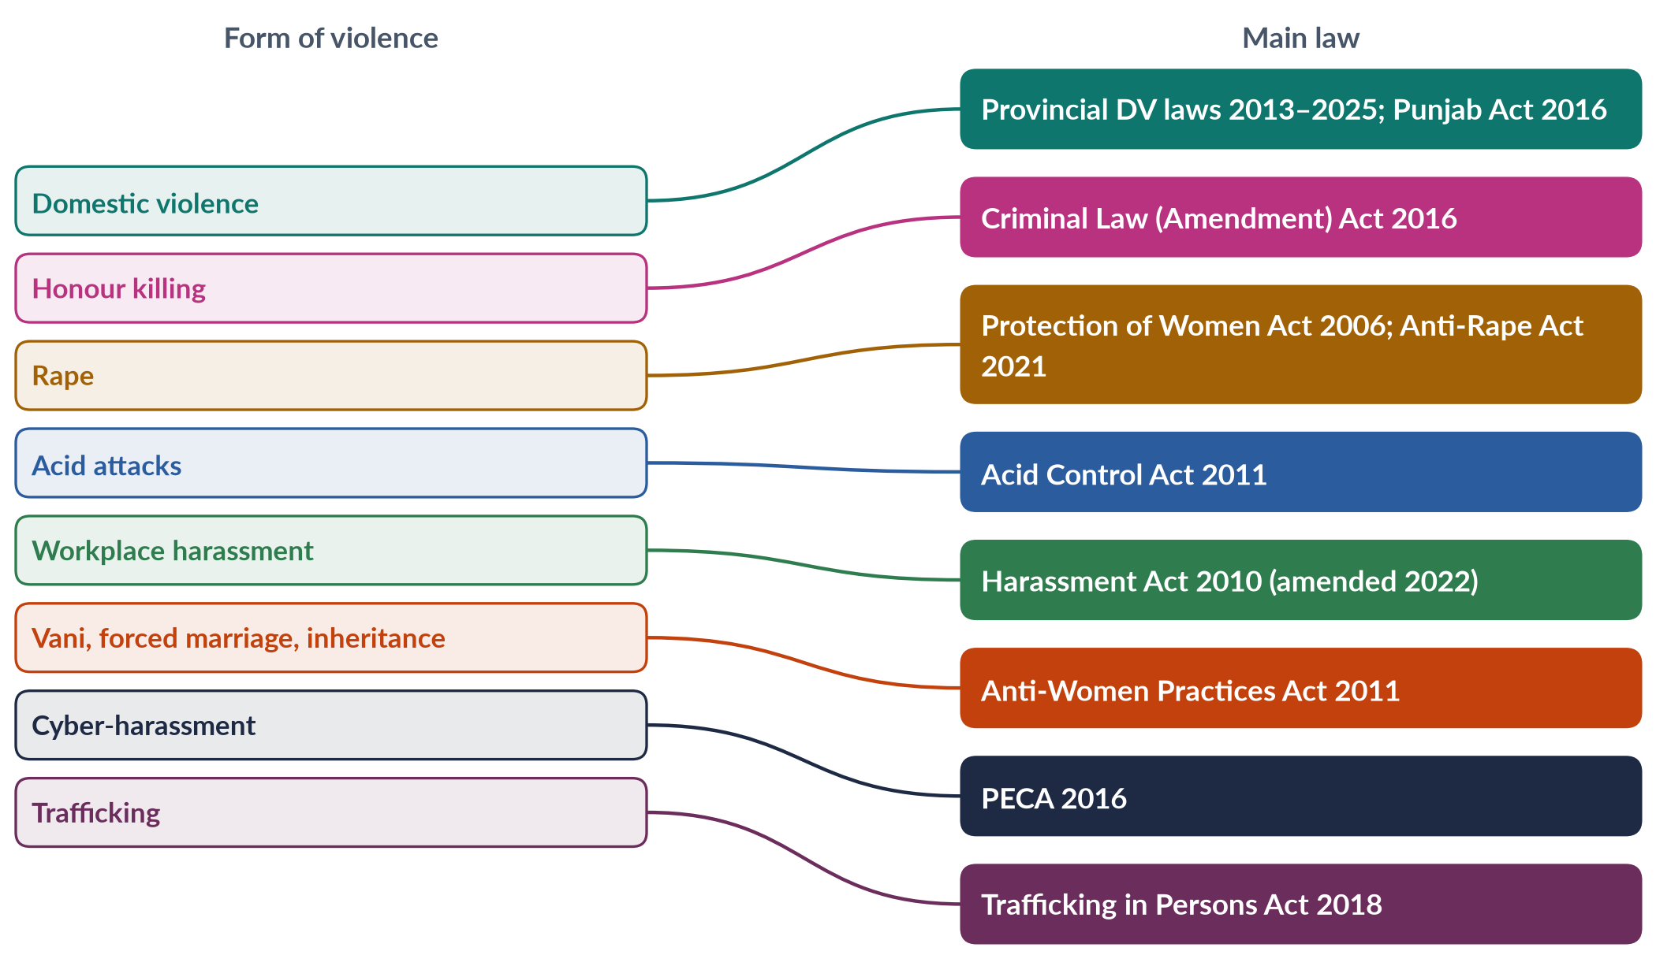
Figure 14 · Forms of violence and the main law addressing each in Pakistan.
EXAMINER'S EYE · ORGANISING A "FORMS" ANSWER
Do not list twenty forms in one paragraph. Group them: (1) by site — home, community, workplace, public spaces, online, state; or (2) by nature — physical, sexual, psychological, economic, custom-based. Give data for at least three forms (PDHS, SSDO, HRCP), a law for each, and a case for two or three (Mukhtaran Mai, Qandeel Baloch, Zainab, the motorway case).

Chapter 6 · Honour Killing
"Honour killing" was a short note in 2017. A 2019 MCQ asked what A Girl in the River was about (honour killing), and a 2026 MCQ asked which law criminalised honour killings and restricted the family-forgiveness loophole (the Criminal Law (Amendment) Act 2016).

6.1 What an honour killing is
An honour killing is the murder of a person — usually a woman or girl — by members of her own family or community, who claim that she has brought shame (be-izzati, be-ghairati) on them by her behaviour. The "offence" may be real or suspected: choosing her own husband, seeking divorce, having a relationship outside marriage, being a victim of rape, talking to a man, refusing an arranged marriage, dressing or behaving "immodestly", or appearing on social media. Men are sometimes killed too, usually the man accused of the relationship.
✦ DEFINITION
Honour killing · Human Rights Watch and UN usage
"Acts of violence, most commonly murder, committed by male family members against female family members who are held to have brought dishonour upon the family."

Local names
Table 7 · Local names for honour killing in Pakistan.
Name | Region | Meaning
Karo-kari | Sindh | Karo (black man) and kari (black woman) — those "blackened" by alleged illicit relations
Siyahkari | Balochistan | "Black deed" — the same concept
Tor tora | Khyber Pakhtunkhwa | "Black" (Pashto) — a person accused of adultery
Kala kali | Punjab | "Black man, black woman"

6.2 The scale of the problem
- HRCP recorded at least 405 honour killings in 2024, most of the victims women.
- SSDO counted 547 reported honour killings in 2024, with a conviction rate of about 0.5% — in Punjab, 225 cases led to only two convictions.
- Many more are hidden: deaths are disguised as suicide or accidents, bodies are buried quickly, and families do not report.

6.3 Why honour killings happen
1. Honour and patriarchy: a family's honour is believed to rest in its women's sexual "purity" and obedience; men are expected to defend it (cultural violence, in Galtung's terms).
2. Control of marriage and property: killing a daughter who marries by choice keeps marriage — and property — under family control; false accusations of karo-kari are sometimes used to grab land, settle disputes or extract compensation.
3. Community pressure: men who do not act may be mocked as be-ghairat (without honour); jirgas may order or approve killings.
4. Impunity: until 2016, killers could be pardoned by the victim's heirs — who were often the killers' own family.
5. Misuse of religion: killers claim religious justification, though Islam does not permit a family to kill; mainstream scholars and the Council of Islamic Ideology have condemned honour killing as murder.

6.4 The legal history
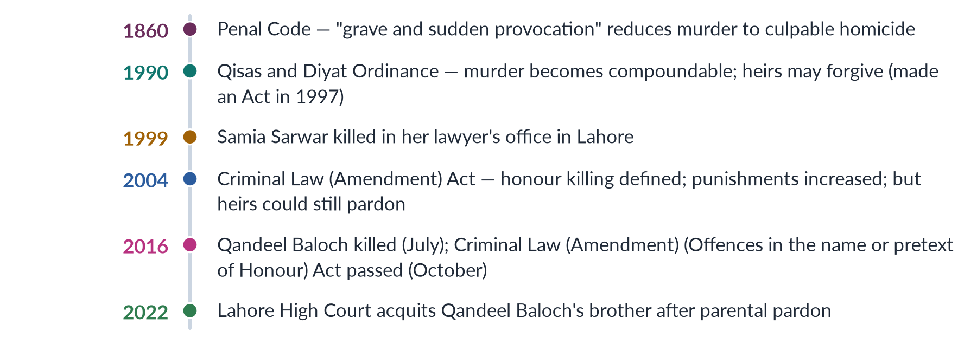
Figure 15 · The law on honour killing in Pakistan.

(1) The "forgiveness loophole"
Under the Qisas and Diyat Ordinance (1990; made permanent by an Act of 1997), murder became a compoundable offence: the heirs of the victim (wali) could forgive the killer, with or without compensation (diyat). In an honour killing, the heirs are usually the killer's own family — parents, siblings — so a father who killed his daughter could be "forgiven" by his wife and other children. Killers walked free.

(2) The 2004 amendment
The Criminal Law (Amendment) Act 2004 defined "offences committed in the name or on the pretext of honour" (karo-kari, siyahkari and similar practices), made them punishable as murder, and raised penalties. But it did not close the pardon loophole.

(3) The 2016 law
✦ LAW & POLICY
Criminal Law (Amendment) (Offences in the name or pretext of Honour) Act 2016 · passed by a joint sitting of Parliament, October 2016
• Where a murder is committed in the name of honour, the heirs may still forgive the death penalty (qisas), but the court must still award imprisonment for life (in Pakistani practice, 25 years) as ta'zir.
• Honour killings were thus made effectively non-compoundable at the level of the minimum punishment.
• The bill had been moved by Senator Sughra Imam in 2014 and stalled; the murder of Qandeel Baloch in July 2016 and the Oscar for A Girl in the River (February 2016) pushed it through.
➜ A 2026 MCQ: the law that criminalised honour killings and restricted the family-forgiveness loophole is the Criminal Law (Amendment) Act 2016.

The weakness: courts must still decide whether a killing was "in the name of honour". Families often claim a different motive, or witnesses turn hostile, so the case is treated as ordinary murder — which can still be compounded.

6.5 Cases that changed the debate
✦ CASE
Samia Sarwar (1999) · killed in her lawyer's office
Samia Sarwar, 29, sought a divorce from an abusive husband. Her mother came to the Lahore office of her lawyers, Hina Jilani and Asma Jahangir, with a gunman, who shot Samia dead. Her family was never punished, and some legislators defended the killing in the Senate. The case drew international attention to impunity.

✦ CASE
Qandeel Baloch (2016) · a social-media star killed by her brother
Qandeel Baloch (Fouzia Azeem), a social-media celebrity known for bold posts, was strangled by her brother Waseem in Multan in July 2016; he said she had dishonoured the family. Her murder led directly to the 2016 law. Waseem was sentenced to life imprisonment in 2019, but the Lahore High Court acquitted him in February 2022 after witnesses retracted and her parents submitted a pardon — showing the limits of the reform.

✦ CASE
Saba Qaiser (2014) · the girl in the river
Saba Qaiser, 19, of a village near Gujranwala, married the man she loved. Her father and uncle shot her in the head, put her in a bag and threw her into a river. She survived. Under pressure from the community, she later "forgave" them. Sharmeen Obaid-Chinoy's A Girl in the River: The Price of Forgiveness won the 2016 Oscar; Prime Minister Nawaz Sharif screened it and said there is "no honour in honour killing" (Chapter 12).

✦ CASE
Bano Satakzai and Ehsanullah Samalani (2025) · a killing caught on video
In June 2025 a newly married couple were shot dead in the Degari area of Balochistan, allegedly on the orders of a tribal chief, because they had married against their families' wishes. When a video of the killing went viral in July 2025, it caused national outrage, and police arrested a number of suspects — showing both the persistence of tribal "justice" and the power of social media to force action.

6.6 Consequences
- For victims: death, or for survivors, lifelong fear, injury and exile from family.
- For women generally: fear restricts choices in marriage, education and work — the "chilling effect".
- For society: a culture of impunity that weakens the rule of law; Pakistan's international image suffers.

6.7 Strategies against honour killing
1. Close remaining loopholes: make honour killings fully non-compoundable; prevent families from re-labelling them as ordinary murder.
2. Investigate and prosecute properly: treat every suspicious death of a woman as possible honour killing; protect witnesses; use forensic evidence.
3. Ban and prosecute jirgas that order killings, and their members.
4. Protect women at risk: safe shelters (Dar-ul-Aman), helplines, police protection for couples who marry by choice — courts often order protection for such couples.
5. Religious leadership: clear statements from scholars that honour killing is murder.
6. Education and media: challenge the idea that honour lives in women's bodies; promote stories of families who reject violence.
7. Women's economic independence and awareness of rights.
BALANCED VIEW · HAS THE 2016 LAW WORKED?
• Gains: a mandatory life sentence even after forgiveness; greater public awareness; more prosecutions and some convictions.
• Limits: hundreds of killings each year (405 in 2024); conviction rates about 0.5%; families re-label motives; witnesses turn hostile; the Qandeel Baloch acquittal (2022).
➜ Line to take: the law was a necessary reform, but impunity continues through settlements, weak investigation and social approval. Enforcement and social change must follow legal change.

EXAMINER'S EYE · THE MODEL STRUCTURE FOR THE 2017 SHORT NOTE
1. Definition and local names. 2. Scale (HRCP 405; SSDO 547 and 0.5% convictions). 3. Causes (honour, control of marriage and property, pressure, impunity). 4. Law: Qisas and Diyat loophole, 2004, 2016. 5. Cases: Samia Sarwar, Qandeel Baloch, Saba Qaiser. 6. Strategies and assessment. About 600 words; draw the timeline.

Chapter 7 · Laws, Policies and Government Initiatives against Violence
"Government initiatives for combating violence against women" was a short note in 2018. The 2024 question asked: "What forms of gender-based violence are given in the Punjab Protection of Women against Violence Act 2016?" A 2026 MCQ asked for the 2016 honour-killing law.

7.1 The constitutional and international framework
- Constitution of 1973: Article 9 (security of person), Article 14 (dignity of man and privacy of home), Article 25 (equality; special provision for women), Article 35 (protection of the family, the mother and the child), Article 37 (just and humane conditions).
- International commitments: CEDAW (acceded 1996) and its General Recommendations 19 and 35; the Beijing Platform (Area D); the ICCPR (2010) and the Convention against Torture (2010); SDG targets 5.2 and 5.3; the EU GSP+ status (2014), which requires effective implementation of 27 conventions.

7.2 The legislative timeline
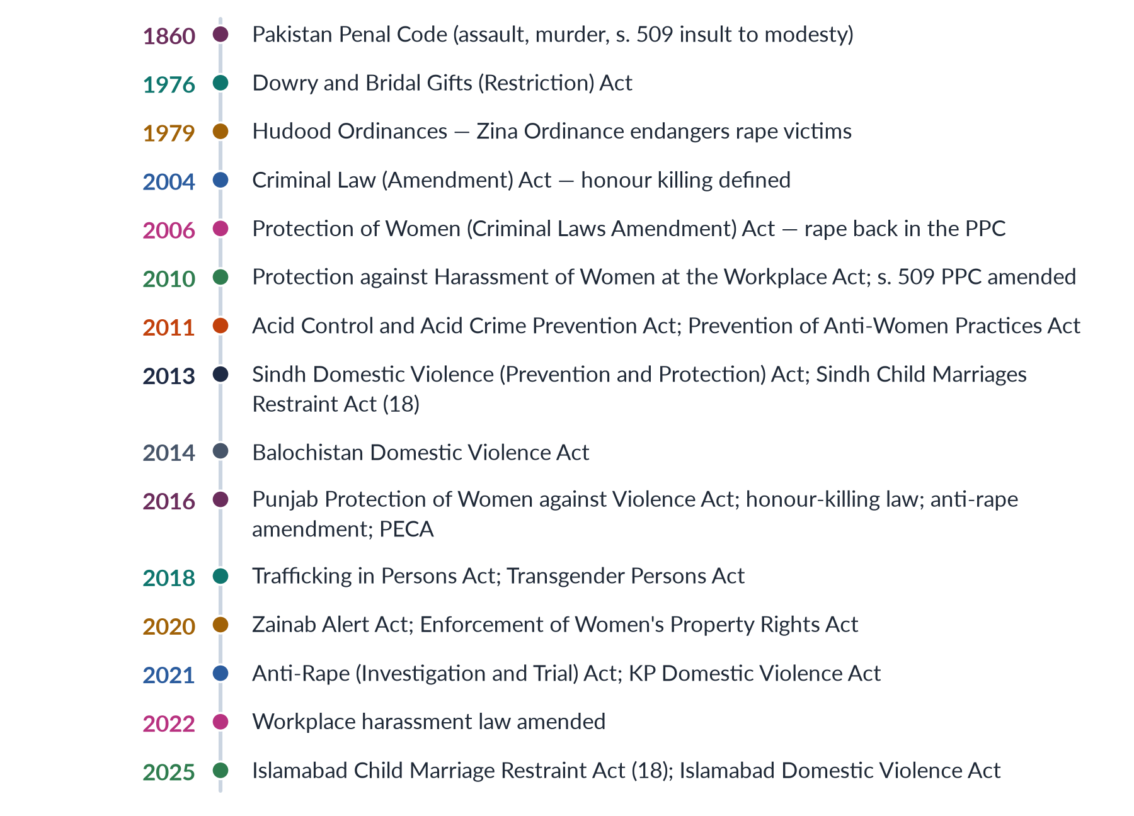
Figure 16 · Pakistan's main laws against violence against women.

Key laws explained
1. Protection of Women (Criminal Laws Amendment) Act 2006 — moved rape from the Zina Ordinance back into the Penal Code, ended the requirement of four witnesses for rape, and stopped the conversion of rape complaints into adultery charges (MCQ 2016).
2. Protection against Harassment of Women at the Workplace Act 2010 — requires every organisation to have an inquiry committee and a code of conduct, and created federal and provincial Ombudspersons; amended in 2022 to widen "workplace" and "employee".
3. Section 509 PPC (2010) — harassment in public places, punishable by up to three years' imprisonment and a fine.
4. Acid Control and Acid Crime Prevention Act 2011 — sections 336A and 336B PPC: 14 years to life imprisonment and a minimum fine of one million rupees.
5. Prevention of Anti-Women Practices Act 2011 — criminalised vani and swara (s. 310A), denial of inheritance (s. 498A), forced marriage (s. 498B) and marriage to the Qur'an (s. 498C).
6. Criminal Law (Amendment) (Offences in the name or pretext of Honour) Act 2016 — mandatory life imprisonment even where heirs forgive.
7. Criminal Law (Amendment) (Offences relating to Rape) Act 2016 — DNA testing, in-camera trials, and penalties for police who obstruct investigation.
8. Prevention of Electronic Crimes Act 2016 — online harassment, stalking and image-based abuse.
9. Anti-Rape (Investigation and Trial) Act 2021 — Special Sexual Offences Investigation Units in districts, Anti-Rape Crisis Cells, special courts, in-camera trials, decisions preferably within four months, and a sex-offenders register.

7.3 The Punjab Protection of Women against Violence Act 2016 (2024)
The Punjab Assembly passed the Act on 24 February 2016; it was published on 29 February 2016. Its aim, in its own words, is "to establish an effective system of protection, relief and rehabilitation of women against violence". It is mainly a civil protection law, not a penal code — it gives women remedies and services.

(1) The forms of violence it names — section 2(r)
Table 8 · Forms of violence under the Punjab Act 2016, section 2(r).
Form | Meaning under the Act, with an example
Abetment of an offence | Helping or encouraging an offence against a woman — e.g. in-laws who incite a husband
Domestic violence | Violence by a person with whom the woman lives or has lived in a house, related by blood, marriage or adoption — e.g. beating by a husband or brother
Sexual violence | Sexual assault, including within the household
Psychological abuse | Oppressive behaviour or restriction of movement causing psychological deterioration — e.g. depression or attempted suicide, certified by a panel of psychologists
Economic abuse | Denial of food, clothing and shelter according to the defendant's income, or taking away the woman's income without consent
Stalking | Following, watching or contacting a woman persistently so as to cause fear
Cybercrime | Offences committed through electronic means — e.g. harassment or blackmail online

(2) The remedies — court orders
A complaint goes to the Family Court, which must fix the first hearing within seven days and decide within 90 days.
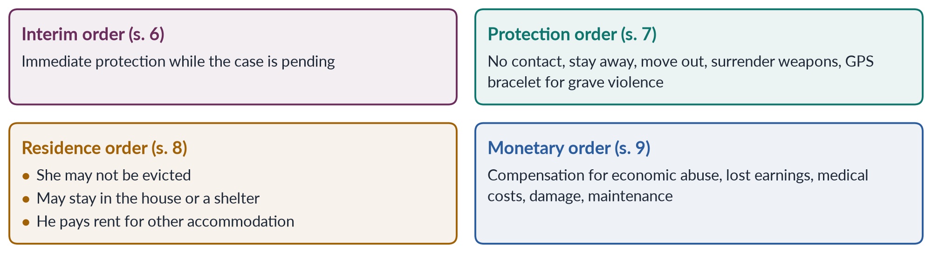
Figure 17 · The orders a court can pass under the Punjab Act 2016.
The protection order's most famous feature was the GPS ankle or wrist bracelet for a defendant who commits or threatens "grave violence". Critics called it un-Islamic and anti-family; it was rarely used in practice.

(3) The protection system
- Universal toll-free helpline (s. 3).
- District Women Protection Committees (s. 11), led by the district administration, with health, police, social welfare and prosecution officers and civil-society members.
- Protection Centres — "Violence against Women Centres" (s. 13): one-stop centres for police reporting, FIR registration, medical examination, forensic evidence within 24 hours, legal aid, counselling and mediation. The first opened in Multan in 2017.
- Shelter homes in each district (s. 13).
- Women Protection Officers (s. 14), who can enter premises (with notice) to rescue a woman.

(4) Penalties
- Breach of an order or tampering with the GPS tracker: up to one year and a fine of Rs 50,000–200,000; repeat breach: one to two years (s. 20).
- False complaint: up to three months or a fine of Rs 50,000–100,000 (s. 19).

(5) Reaction and assessment
BALANCED VIEW · THE PUNJAB ACT 2016 — PRAISE AND CRITICISM
• Praise: the first law in Pakistan to recognise economic and psychological abuse, stalking and cybercrime as violence; a fast-track civil remedy; one-stop centres that bring police, doctors and lawyers under one roof; a model for other provinces.
• Criticism: religious parties and the Council of Islamic Ideology called it "un-Islamic" and a threat to the family; mediation and reconciliation provisions can push women back into abusive homes; implementation was slow — few centres beyond Multan, limited staff and funds; low awareness among women.
➜ Line to take: a progressive law in design, whose impact depends on implementation — centres in every district, trained staff and public awareness.

7.4 Other provincial laws
- Sindh Domestic Violence (Prevention and Protection) Act 2013 — the first provincial DV law; protection orders and penalties.
- Balochistan Domestic Violence (Prevention and Protection) Act 2014.
- Khyber Pakhtunkhwa Domestic Violence against Women (Prevention and Protection) Act 2021 — after years of opposition.
- Islamabad (ICT) Domestic Violence (Prevention and Protection) Act 2025 — moved by Sharmila Farooqui; passed by the National Assembly (13 November) and the Senate (28 November 2025).

7.5 Government initiatives and institutions (2018)
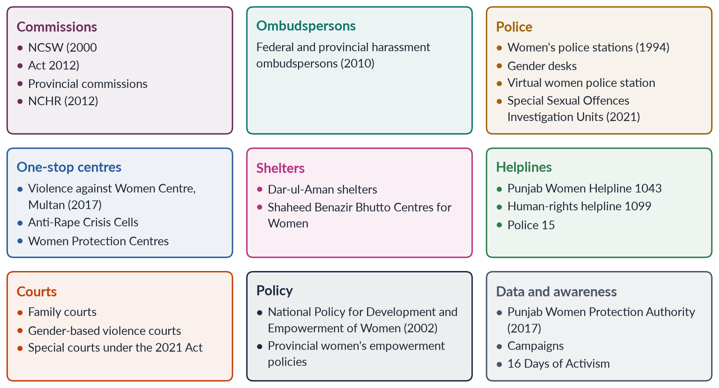
Figure 18 · Government initiatives against violence against women in Pakistan.
1. National Commission on the Status of Women (NCSW) — set up in 2000, made statutory by the NCSW Act 2012; reviews laws and policies and recommends reforms.
2. Women's police stations — first established in 1994 under Benazir Bhutto; today supplemented by gender protection units and women's help desks in police stations.
3. Shelters — Dar-ul-Aman homes run by social welfare departments, and crisis centres for women.
4. Helplines — the Punjab Women Helpline 1043, the federal 1099 human-rights helpline, and police emergency 15.
5. Violence against Women Centre, Multan (2017) — the first one-stop centre under the Punjab Act.
6. Punjab Women Protection Authority (2017) — to run the protection system.
7. Courts — special gender-based violence courts piloted in Punjab from 2017, and special courts under the Anti-Rape Act 2021; Sindh reported a rise in conviction rates in districts with such courts.
8. Ombudspersons for workplace harassment and for women's property rights (2020).
9. Social protection — the Benazir Income Support Programme (2008), paid to women, which some studies link to greater bargaining power at home.

7.6 The enforcement gap
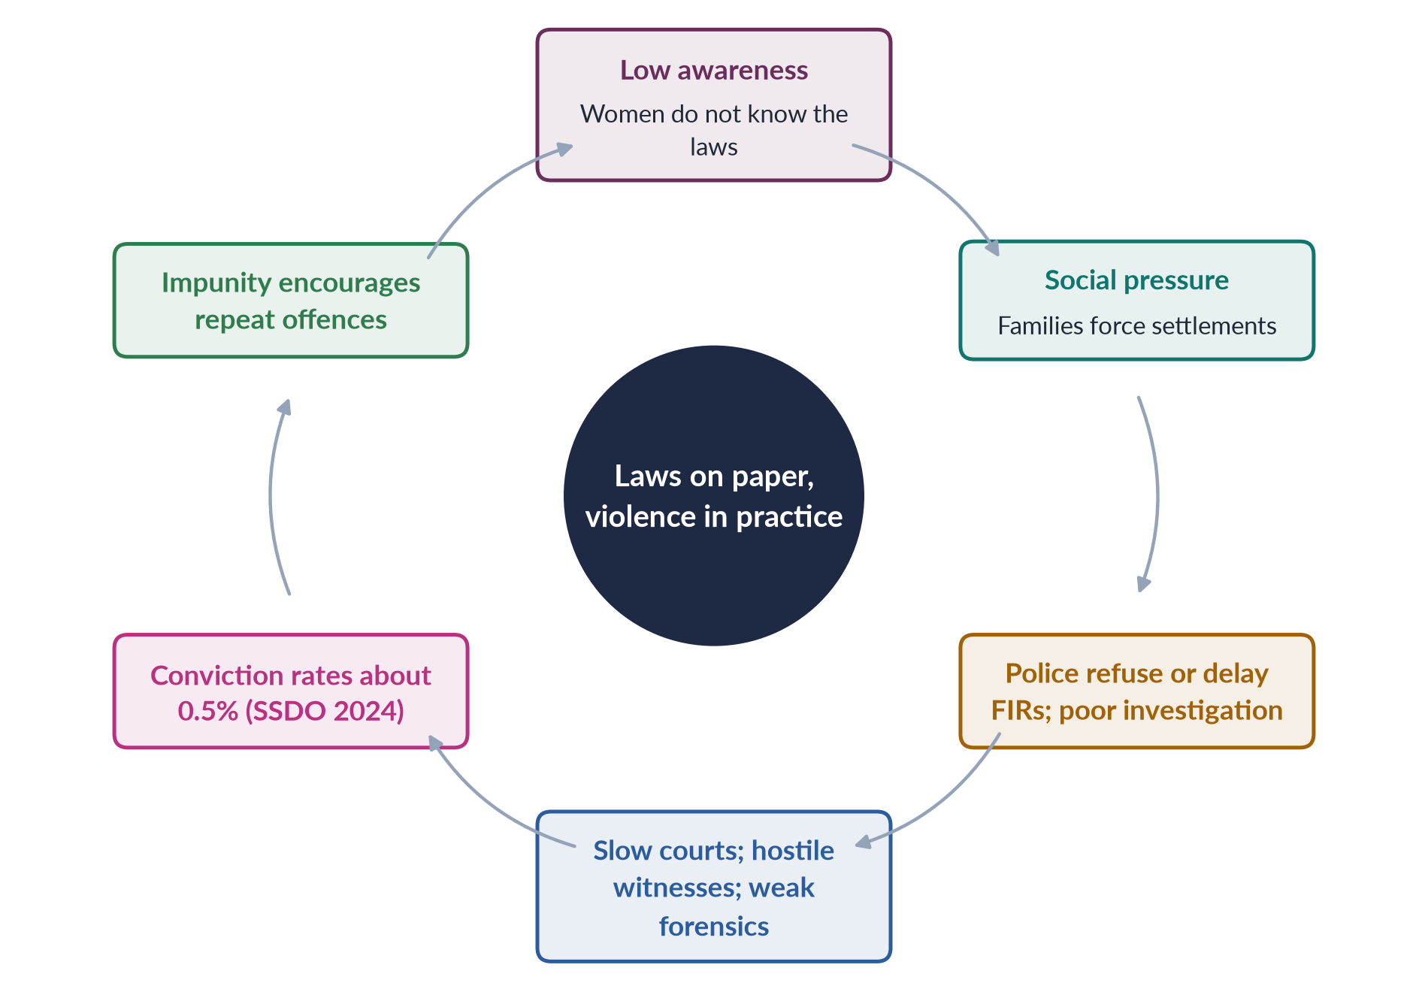
Figure 19 · Why laws have not stopped violence — the enforcement gap.
The main problem is not a lack of laws but their implementation: low awareness, police attitudes, few women police, poor forensic capacity, slow courts, compromise and pardons, too few shelters, and uneven provincial capacity after the 18th Amendment (2010).
EXAMINER'S EYE · THE MODEL STRUCTURE FOR THE 2018 NOTE
1. Framework (Constitution, CEDAW, SDG 5.2). 2. Laws (2006, 2010, 2011, 2016, 2021). 3. Institutions (NCSW, women's police stations, ombudspersons). 4. Services (VAWC Multan 2017, 1043 helpline, shelters). 5. Courts and investigation units. 6. Assessment — the enforcement gap. About 600 words; draw the grid.

Chapter 8 · Consequences of Gender-Based Violence and Strategies to Eliminate It
"What are the consequences of gender-based violence for women?" (2024). "How in your view this menace can be eliminated from our society?" (2016); "What could be the workable strategies to eliminate gender-based violence from Pakistani society?" (2017); "Devise practical strategies helpful in eradicating gender-based violence" (2023).

8.1 The consequences of GBV
Violence harms not only the woman attacked but her children, her family, the economy and society as a whole.
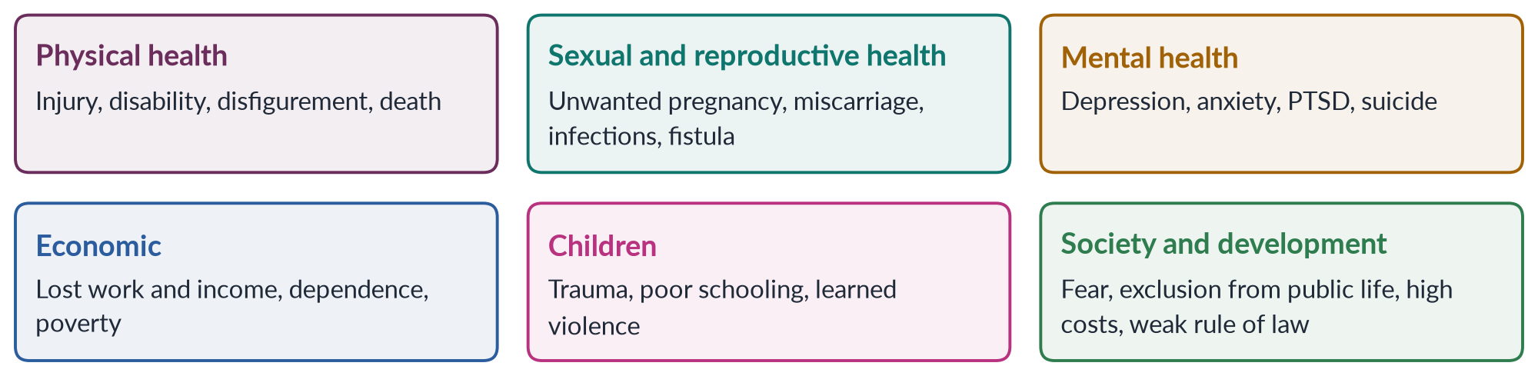
Figure 20 · The consequences of gender-based violence.

(1) Physical health
- Injuries — bruises, fractures, burns, broken teeth, eye and ear damage; acid attacks cause blindness and lifelong disfigurement.
- Death — honour killings, dowry murders, femicide. Worldwide about 51,100 women and girls were killed by partners or family members in 2023 (UNODC and UN Women).
- Long-term illness — chronic pain, digestive problems and disability.

(2) Sexual and reproductive health
- Unwanted pregnancies and unsafe abortions; miscarriage and low birth weight when pregnant women are beaten.
- Sexually transmitted infections, including HIV.
- Marital rape and early marriage contribute to obstetric fistula and maternal death.

(3) Mental health
The WHO finds that women who experience partner violence are almost twice as likely to experience depression. Survivors suffer anxiety, post-traumatic stress, low self-esteem, sleep and eating disorders, substance use and suicidal thoughts. The Punjab Act's definition of psychological violence recognises outcomes such as depression and suicide attempts.

(4) Economic consequences
- Women lose work days and jobs; some are forbidden to work at all (economic abuse).
- Fear of harassment keeps women out of jobs, colleges and public transport — one reason female labour-force participation is only 24.4%.
- Survivors who leave abusive homes often fall into poverty, especially without inheritance or maintenance.

(5) Consequences for children
Children who witness violence suffer trauma, behavioural problems and poor school performance; boys are more likely to become abusers and girls to accept abuse — the intergenerational cycle described by social learning theory. Child and forced marriage end girls' schooling.

(6) Social and development consequences
- Fear limits women's mobility and participation in politics and public life (Topic 6).
- Costs: health care, police, courts, shelters and lost productivity. Global estimates put the cost of violence against women at around 2% of world GDP.
- Rule of law: impunity for violence weakens trust in the state.
- Development: violence undermines progress on health, education and employment — SDG 5, and SDGs 3, 4, 8 and 16.
PAKISTAN ANGLE · SILENCE AS A CONSEQUENCE
In the PDHS 2017–18, 56% of women who had experienced physical or sexual violence had never sought help or told anyone. Silence is itself a consequence of violence — of shame, fear and lack of services — and it hides the true scale of the problem.

8.2 Principles for strategy
Workable strategies must (1) attack root causes, not only symptoms; (2) work at all levels of the ecological model; (3) be survivor-centred — putting the woman's safety, choices and dignity first; and (4) be realistic about Pakistan's resources and institutions.
The international framework, from the Istanbul Convention (2011) and the UN, organises strategy into the "four Ps" — Prevention, Protection, Prosecution and Policies (integrated policies). A useful Pakistani version adds Provision of services and Partnership — the "five Ps".
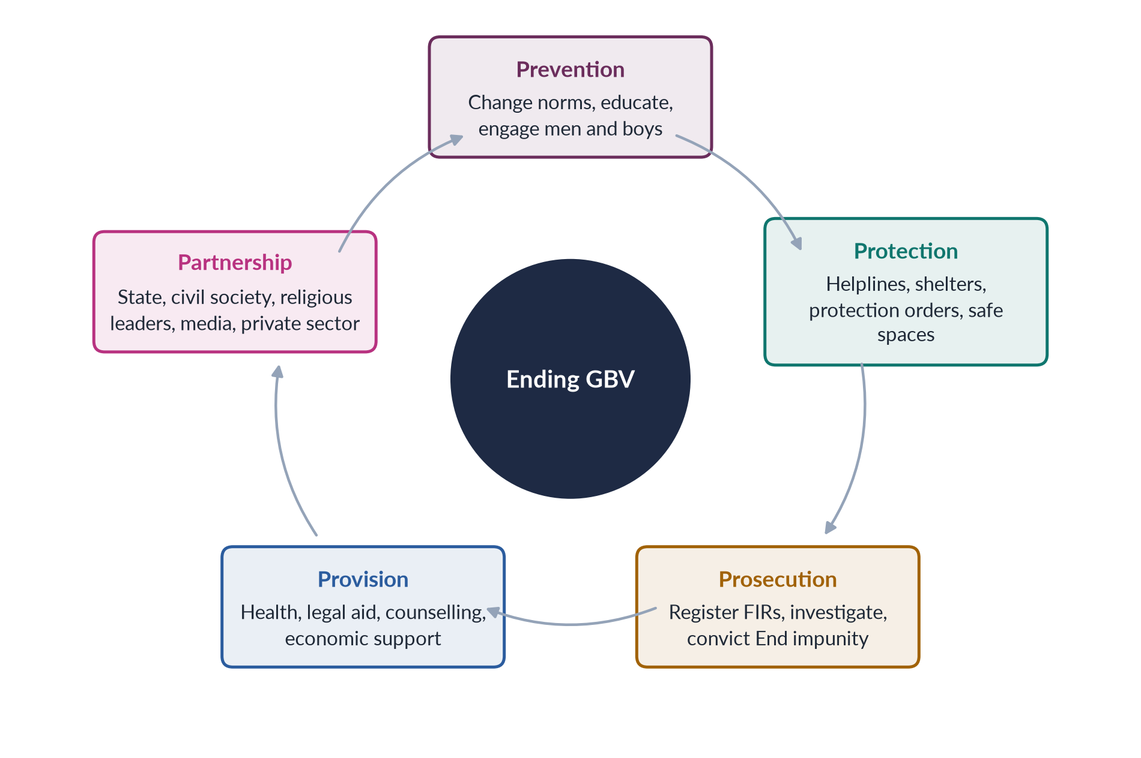
Figure 21 · The five Ps — a framework of strategies to eliminate GBV.

8.3 Prevention — stopping violence before it starts
1. Education: gender-equality lessons and life skills in schools; teaching respect, consent and non-violent conflict resolution; keeping girls in school (education delays marriage and raises women's bargaining power).
2. Engaging men and boys: programmes that challenge harmful ideas of masculinity — for example, the work of the Pakistani NGO Rozan with boys, young men and police (Chapter 9).
3. Religious scholars: mobilising imams and scholars to declare clearly that honour killing, forced marriage, denial of inheritance and wife-beating are contrary to Islam; Friday sermons and khutbas reach millions.
4. Media: responsible reporting; dramas that show respectful relationships; campaigns during the 16 Days of Activism; regulation of content that glorifies abuse.
5. Economic empowerment: women's jobs, property and inheritance, microfinance and BISP payments increase women's bargaining power and ability to leave abuse.
6. Ending child marriage: raise the minimum age to 18 nationwide, as Sindh (2013) and Islamabad (2025) have done; register all marriages.

8.4 Protection — keeping women safe
1. Helplines that answer around the clock — the Punjab Women Helpline 1043, the 1099 human-rights helpline, the Digital Rights Foundation cyber-harassment helpline.
2. Protection orders under the Punjab Act 2016 and the DV laws — enforced, not just issued.
3. Shelters (Dar-ul-Aman) that are safe, dignified and linked to rehabilitation, rather than places of confinement.
4. One-stop centres like the Violence against Women Centre, Multan (2017), in every district.
5. Safe public spaces — women-only transport, lighting, CCTV, safe-city projects.
6. Protection of couples who marry by choice, and of witnesses.

8.5 Prosecution — ending impunity
1. Compulsory FIR registration and action against police who refuse.
2. More women police and gender-sensitive training for police, prosecutors and judges.
3. Forensic capacity — DNA laboratories and medico-legal officers, including women doctors.
4. Special courts under the Anti-Rape Act 2021 and gender-based violence courts, with fast, in-camera trials.
5. Close loopholes — make honour killings and other GBV crimes non-compoundable; restrict pressured "compromises".
6. Act against jirgas that order violence.

8.6 Provision of services
Free legal aid, medical care, psychological counselling, vocational training and economic support so that survivors can rebuild their lives; services in local languages; special attention to rural, minority and disabled women.

8.7 Partnership and policy
- Co-ordination between police, health, social welfare, courts and NGOs (the Duluth "co-ordinated community response").
- Data: a national database of GBV cases, published regularly.
- Funding for commissions, shelters and centres.
- Civil society: NGOs such as the Aurat Foundation, Shirkat Gah, Rozan, War Against Rape and the Acid Survivors Foundation provide services and advocacy.
- Provincial harmonisation after the 18th Amendment, so that every province has comparable laws and services.

8.8 Strategies by ecological level
Table 9 · Strategies mapped to the four levels of the ecological model.
Level | Workable strategies
Society | Enforce laws; close loopholes; national campaigns; religious leaders' statements; women's economic rights
Community | Act against jirgas; community mobilisation; safe transport; local women's committees; Lady Health Workers as first responders
Relationship | Marriage registration and 18-year age; family counselling; pre-marriage education; women's control of income (BISP)
Individual | Schooling for girls; life-skills for boys; perpetrator programmes; counselling and support for survivors

8.9 What makes a strategy "workable"? (2017)
BALANCED VIEW · AMBITIOUS OR REALISTIC?
• Ambitious strategies — changing patriarchal norms, transforming masculinity — are essential but slow.
• Realistic, quick wins — FIR registration, special courts, helplines, one-stop centres in every district, enforcing existing laws — can reduce impunity now.
➜ Line to take: combine quick wins in enforcement and services with long-term prevention. A workable strategy uses existing laws and institutions better, rather than waiting for new ones.

EXAMINER'S EYE · THE MODEL STRUCTURE FOR 2016, 2017 AND 2023
1. Definition and data. 2. Theory (power and control; ecological model). 3. Forms (grouped by site or nature). 4. Causes in brief. 5. Strategies — the five Ps, with Pakistani examples (1043, VAWC Multan, Anti-Rape Act 2021, Rozan). 6. Assessment — enforcement gap. 7. Conclusion. Re-cut for each question: 2016 stresses sites; 2017 stresses workable strategies; 2023 stresses practical strategies after a definition.

Chapter 9 · Masculinities and Violence against Women
"The role of masculinity studies in understanding violence against women in Pakistani society" (short note, 2026). Topic 1 introduced masculinities; this chapter applies them to violence.

9.1 What masculinity studies is
Masculinity studies (or men and masculinities studies) examines how ideas of manhood are socially constructed, how they vary across cultures and history, and how they shape men's behaviour, health and relationships. It grew in the 1980s alongside feminism, asking not only "what happens to women?" but "what makes men act as they do?" Its central claim is that there is no single, natural masculinity — there are masculinities, ranked in a hierarchy.

9.2 Connell and hegemonic masculinity
✦ THINKER
R. W. (Raewyn) Connell · *Gender and Power* (1987); *Masculinities* (1995)
Connell argued that in every society one form of masculinity is hegemonic — the culturally honoured ideal that legitimises men's dominance over women and over other men. Most men do not fully live up to it, but they benefit from the "patriarchal dividend" — the advantages men gain from the overall subordination of women. Below it are complicit, marginalised and subordinated masculinities.
➜ The key concept for linking masculinity and violence: violence is often a way of performing or defending hegemonic masculinity.

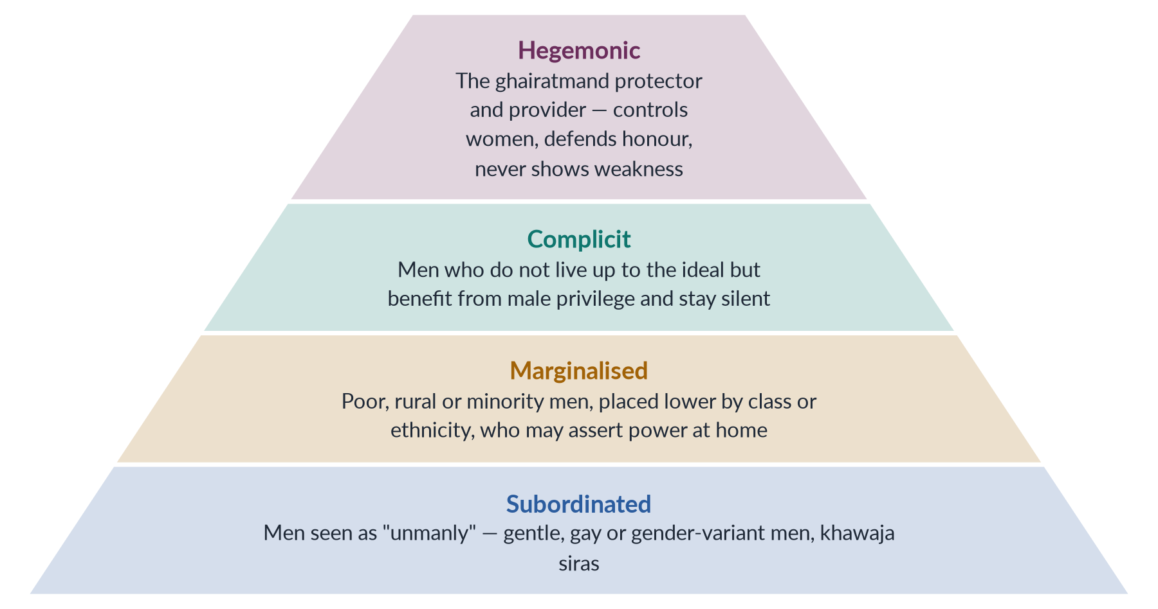
Figure 22 · Connell's hierarchy of masculinities, applied to Pakistan.

9.3 How masculinity studies explains violence
1. Violence as proof of manhood. Where manhood is defined by toughness, control and protecting "honour", violence becomes a way to prove one is a "real man" — especially when other routes (a good job, status) are blocked.
2. Honour and ghairat. In Pakistan, a man's honour (ghairat, izzat) is tied to the behaviour of "his" women. Masculinity studies shows that honour killing is not only about controlling women but about men's fear of being judged be-ghairat (without honour) by other men.
3. Entitlement. Hegemonic masculinity teaches men that they are entitled to obedience, sex and service from women; refusal — of a marriage proposal, of sex, of control — is treated as a challenge. Acid attacks on women who refuse proposals, and the killing of Sana Yousaf (2025) after she rejected a man's advances, fit this pattern.
4. Emotional restriction. Boys are taught not to cry or show fear; anger becomes the one acceptable emotion, and violence its outlet.
5. Masculinity under stress. Unemployment, poverty and migration can create a "crisis of masculinity" — men unable to be providers may assert dominance at home (linking to resource theory).
6. Peer groups and institutions. Violence is reinforced by male peer groups, jirgas, sometimes the police, and media that glorify the "tough" hero.
✦ THINKER
Michael Kaufman · "The Construction of Masculinity and the Triad of Men's Violence" (1987)
Kaufman argued that men's violence forms a triad: violence against women, violence against other men, and violence against themselves (risk-taking, substance abuse, suicide). All three come from the same rigid, armoured masculinity built on suppressing emotion and proving power.
➜ Shows that harmful masculinity hurts men too — a powerful argument for engaging men in prevention.

Michael Kimmel (Guyland, 2008; Angry White Men, 2013) showed how young men's sense of "aggrieved entitlement" — the feeling that what they deserve has been taken away — can turn into violence against women.

9.4 Masculinities in Pakistani society
- The provider and protector ideal: men are expected to earn, decide and protect female relatives — and to control them.
- Ghairat and honour: central to honour killings, acid attacks and forced marriage.
- Socialisation: sons are given freedom and authority; daughters are taught obedience. Boys learn early that "real men" are tough and in charge.
- Media and popular culture: films and dramas often show possessive, jealous heroes as romantic; "stalking" a woman is shown as love.
- Marginalised men: poor or unemployed men, frustrated by inability to meet the provider ideal, may assert power over wives and daughters.
- Subordinated masculinities: khawaja siras and men seen as effeminate face ridicule and violence — gendered violence against men.

9.5 The role of masculinity studies in understanding VAW (2026)
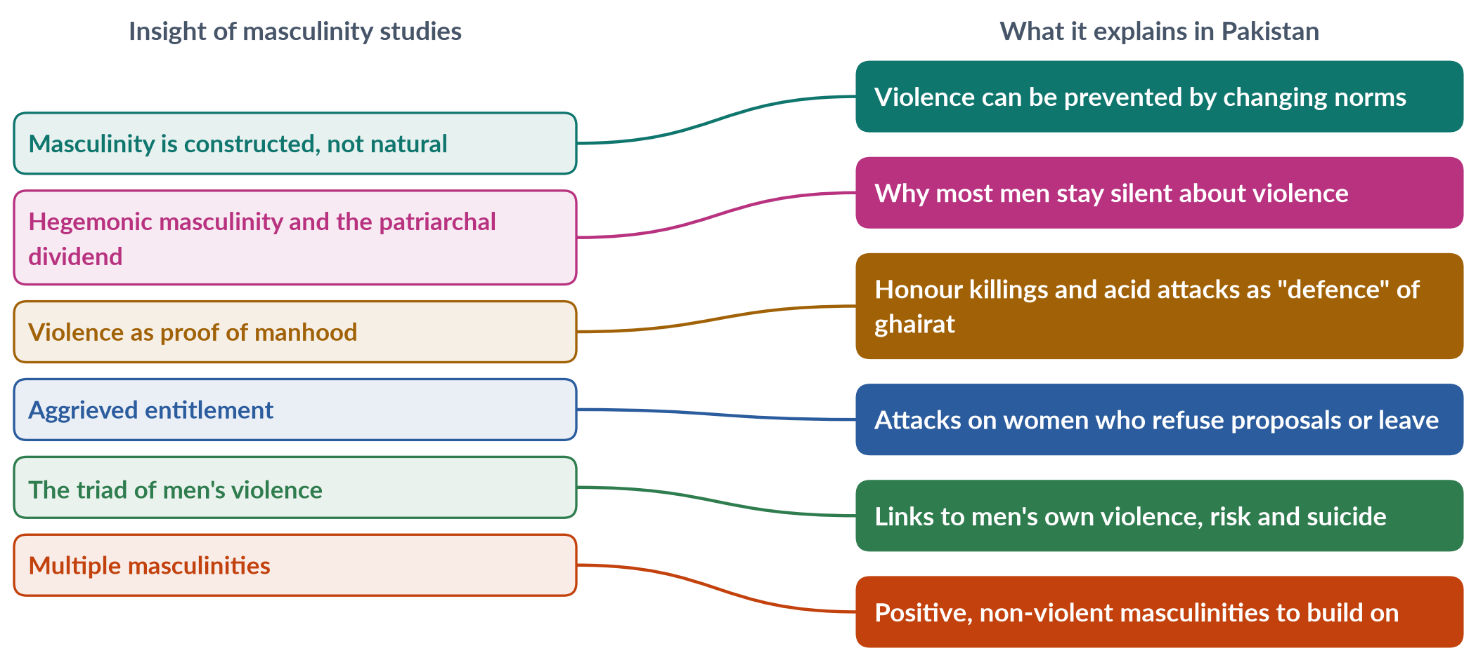
Figure 23 · What masculinity studies adds to the understanding of violence against women.
1. It shifts the focus to men — the main perpetrators — instead of asking only why women "stay" or "provoke".
2. It shows that violence is learned, not natural — so it can be unlearned (social learning theory).
3. It explains honour violence as a performance of masculinity before other men.
4. It explains why most men are silent — they benefit from the patriarchal dividend, or fear being seen as weak.
5. It points to solutions — engaging men and boys, promoting positive masculinities, and changing institutions.

9.6 Engaging men and boys — practice
- Rozan (Islamabad, founded 1998) runs programmes with boys and young men on gender, emotions and violence, and trains police on gender-sensitive policing.
- MenEngage Alliance and the White Ribbon Campaign (founded in Canada, 1991) mobilise men against violence.
- UN Women's HeForShe campaign (2014) invites men to stand for gender equality.
- Religious leaders — male scholars who preach that the Prophet (peace be upon him) never struck a woman and that honour killing is murder model non-violent masculinity.
- Fathers who support daughters' education and choices — such as Ziauddin Yousafzai, Malala's father — are powerful examples of alternative masculinity.
BALANCED VIEW · STRENGTHS AND LIMITS OF MASCULINITY STUDIES
• Strengths: explains why men commit most violence and why it takes honour-based forms; shows that masculinity can change; points to prevention through men.
• Limits: risks shifting attention and funding away from women survivors; "engaging men" programmes vary in effectiveness; must not excuse violence as the product of "stressed" masculinity; concepts from the West need adapting to Pakistani realities.
➜ Line to take: masculinity studies is essential for understanding and preventing violence against women in Pakistan — it explains ghairat-based violence and male silence — but it must complement, not replace, women-centred protection and justice.

EXAMINER'S EYE · THE MODEL STRUCTURE FOR THE 2026 NOTE
1. Define masculinity studies; Connell's hegemonic masculinity and patriarchal dividend. 2. How it explains violence: proof of manhood, ghairat, entitlement, emotional restriction, stress (Kaufman, Kimmel). 3. Pakistani masculinities and cases (honour killings, acid attacks, Sana Yousaf 2025). 4. Its role: focus on men, violence learned, solutions. 5. Engaging men (Rozan, HeForShe, Ziauddin Yousafzai). 6. Limits and conclusion. About 600 words; draw the pyramid.

Part One-B — The Three Case Studies
Syllabus Head IX names three Pakistani women whose lives illuminate gender-based violence and resistance: Mukhtaran Mai (survivor and activist), Malala Yousafzai (education activist and Nobel laureate) and Sharmeen Obaid-Chinoy (Oscar-winning filmmaker). For each, learn the background, the event, the response (legal, social, global) and an evaluation.

Chapter 10 · Case Study I: Mukhtaran Mai
"Explain the structural and direct forms of violence against women in Pakistani society by highlighting the case study of Mukhtaran Mai" (2019). A 2016 MCQ asked where Mukhtaran Mai belonged (South Punjab).

10.1 Background
Mukhtaran Bibi — later known as Mukhtar Mai ("Mai" is a term of respect for an elder sister or woman) — belonged to the Tatla (Gujjar) clan of Meerwala, a village in Muzaffargarh district in South Punjab. The village was dominated by the more powerful Mastoi (Baloch) clan, which controlled land and the local panchayat. She was uneducated, divorced, and taught the Qur'an to village children.

10.2 The event — 22 June 2002
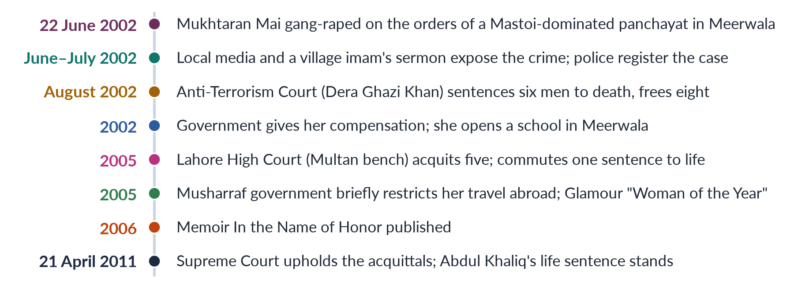
Figure 24 · The Mukhtaran Mai case, from the crime to the Supreme Court.
Mukhtaran Mai's 12-year-old brother, Shakoor, was accused by the Mastoi men of having a relationship with a Mastoi woman, Salma (Shakoor was himself sexually assaulted by Mastoi men, which the family said the accusation was meant to cover up). The Mastoi-dominated panchayat met to "settle" the matter. Mukhtaran Mai went to apologise on behalf of her family. Instead, the council ordered that she be gang-raped as "punishment" — "honour" revenge for the alleged offence of her brother. She was raped by four men and made to walk home before villagers, partly unclothed.

10.3 Breaking the silence
Custom expected a woman in her position to remain silent — or to commit suicide to erase the "shame". Mukhtaran Mai did neither. A local imam condemned the crime in his Friday sermon; a journalist reported it; the story reached national and then international media. With her family's support, she registered a case with the police.

10.4 The legal journey
1. Anti-Terrorism Court (2002): in August 2002, the court in Dera Ghazi Khan convicted six men — four rapists and two panchayat members — and sentenced them to death; it acquitted eight others.
2. Lahore High Court (2005): in 2005, the Multan bench acquitted five of the six for insufficient evidence and commuted the sentence of one, Abdul Khaliq, to life imprisonment. The Federal Shariat Court and the Supreme Court briefly intervened, and the accused were re-arrested pending appeal.
3. Supreme Court (2011): on 21 April 2011, the Supreme Court upheld the High Court's acquittals of the five and maintained Abdul Khaliq's life sentence. Her review petition was later dismissed.
The outcome — nine years of litigation and only one conviction — showed the weaknesses of investigation, evidence and the justice system in rape cases.

10.5 From victim to activist
- Education: with compensation from the government (about 500,000 rupees) she founded the Mukhtar Mai Girls' Model School in Meerwala — the village's first girls' school — and later a boys' school.
- Organisation: the Mukhtar Mai Women's Welfare Organisation provides shelter, legal aid and support to survivors of violence, and runs a helpline and an ambulance.
- Recognition: Glamour magazine's Woman of the Year (2005) and many international awards; her memoir In the Name of Honor (2006) was translated into many languages.
- Personal life: in 2009 she married Nasir Abbas Gabol, a police constable who had been assigned to protect her.

10.6 The government's response and controversy
In 2005 the Musharraf government briefly placed her on the Exit Control List, preventing her from travelling to the United States, apparently to avoid international embarrassment; it reversed the decision after protests. In a widely reported interview, President Pervez Musharraf suggested that some women claimed rape to get visas and money — remarks that caused outrage at home and abroad. The episode showed how the state treated survivors who spoke out as a threat to the country's image.

10.7 Analysis — structural and direct violence (2019)
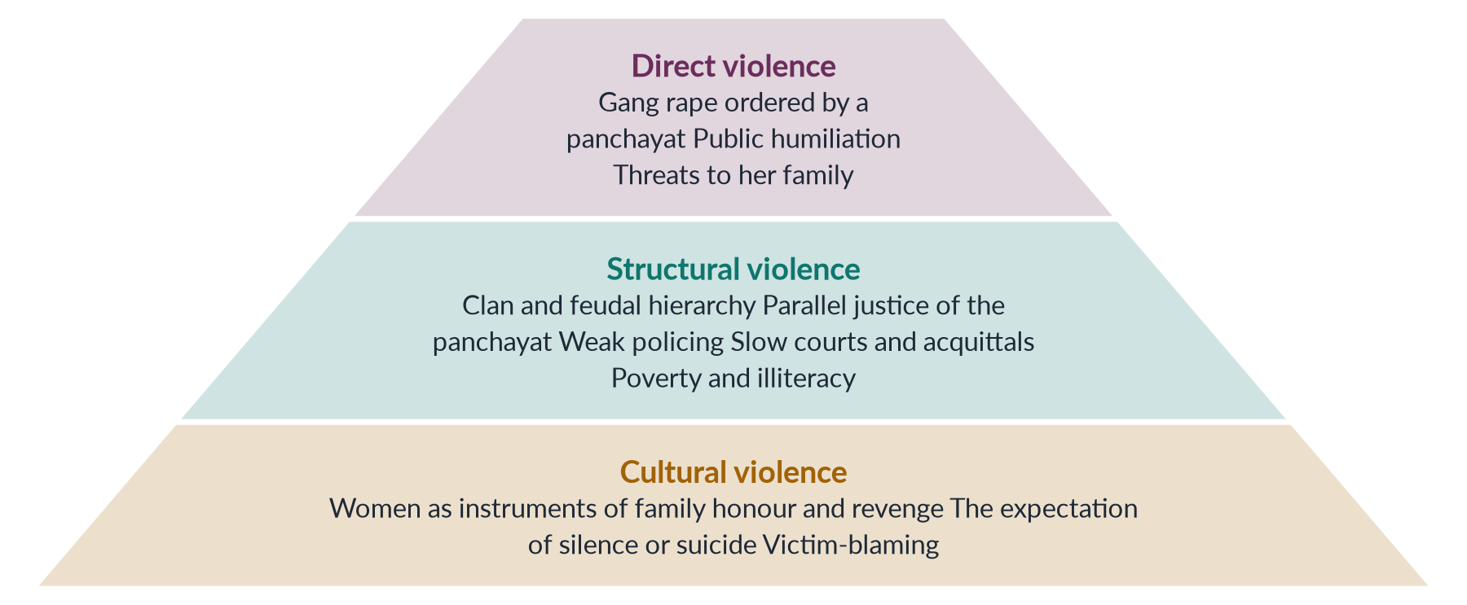
Figure 25 · The Mukhtaran Mai case through Galtung's triangle.

(1) Direct violence
The gang rape itself, ordered by the council and carried out by four men; the public humiliation; and later threats to her and her family.

(2) Structural violence
- Clan and feudal hierarchy: the Mastoi clan's power over land and the panchayat allowed it to impose punishment on a weaker clan.
- Parallel justice: an unofficial panchayat acting as judge, using women's bodies to settle disputes.
- The justice system: delays, weak investigation and forensic evidence, and acquittals — a structure that denies justice without anyone "hitting" anyone.
- Poverty and illiteracy: her family's low status and lack of resources made them vulnerable.

(3) Cultural violence
The belief that a woman can be used to repay a family's "honour" debt; the expectation that a raped woman should be silent or kill herself; victim-blaming by officials.

10.8 Impact and significance
1. National debate: the case exposed the reality of jirga and panchayat "justice" and of rape as punishment.
2. Law reform: it fed the debate that led to the Protection of Women (Criminal Laws Amendment) Act 2006, which moved rape out of the Hudood Ordinances.
3. Global symbol: Mukhtaran Mai became an international symbol of courage — showing that a poor, illiterate village woman could break the silence.
4. Education as resistance: by building schools, she turned a personal tragedy into social change, attacking the illiteracy and ignorance that sustain violence.
BALANCED VIEW · EVALUATING THE MUKHTARAN MAI CASE
• Victory: she broke the silence, won national and global support, built schools and an organisation, and inspired other survivors to speak out.
• Failure of justice: only one of the accused remained convicted after nine years; she lived under threat; the state worried more about its image than about justice.
➜ Line to take: the case is a story of individual courage against structural injustice — it changed the national conversation and contributed to the 2006 reform, but its legal outcome shows how far Pakistan's justice system still is from protecting survivors.

EXAMINER'S EYE · USING THE CASE
For 2019, do not just tell the story: analyse it with Galtung's triangle — direct (the rape), structural (clan hierarchy, panchayat, courts), cultural (women as honour). End with what the case changed: the 2006 Act, national awareness, and her schools.

Chapter 11 · Case Study II: Malala Yousafzai
"Critically examine and evaluate Malala Yousafzai's achievements and activism for promoting girls' education in local and global contexts" (2025). MCQs asked her year of birth (1997, 2016) and the cause she works for internationally (education, 2019).

11.1 Background
Malala Yousafzai was born on 12 July 1997 in Mingora, in the Swat valley of Khyber Pakhtunkhwa. Her father, Ziauddin Yousafzai, a teacher and education activist, ran a chain of schools, the Khushal Public School. Unusually for the region, he celebrated his daughter's birth and encouraged her to speak her mind. She was named after Malalai of Maiwand, a Pashtun heroine.

11.2 Swat under the Taliban
From 2007, the Tehrik-e-Taliban Pakistan (TTP), led in Swat by Maulana Fazlullah, gained control of much of the valley. Using an illegal FM radio station, they announced bans on music, television and women's public life, and in December 2008 ordered that girls' schools close from mid-January 2009. They blew up or burned more than 100 girls' schools. A military operation (2009) later drove them out.

11.3 The activist emerges
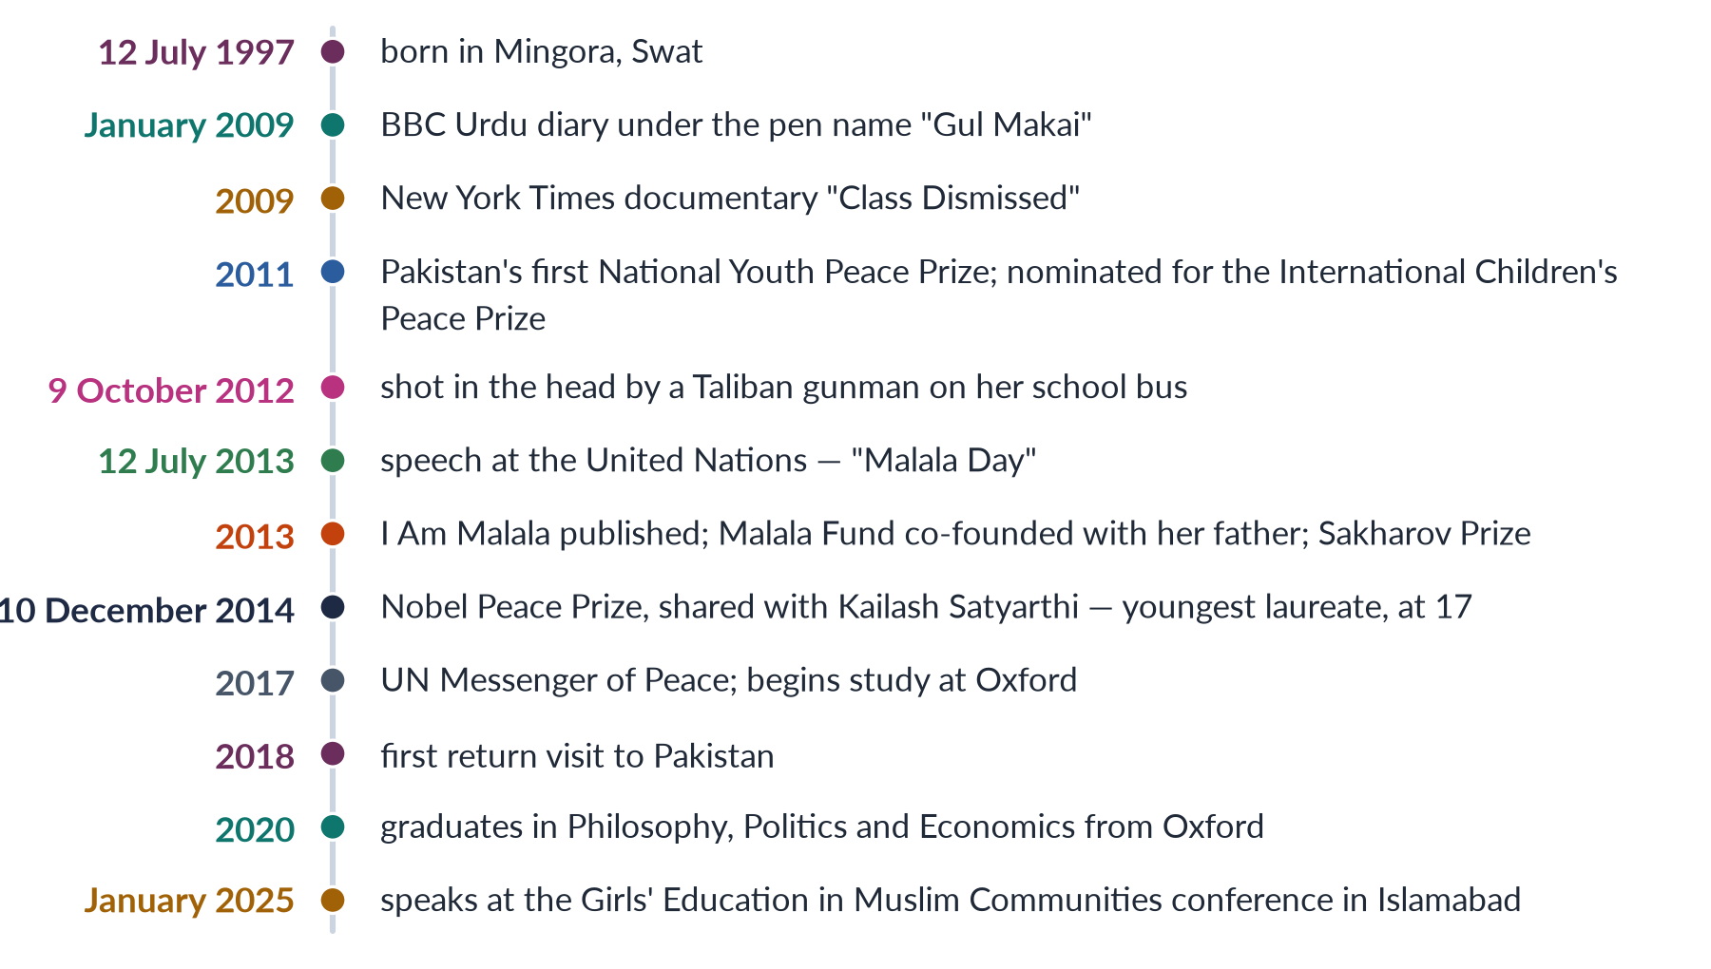
Figure 26 · Malala's journey.
- The BBC diary (2009): at the age of 11, writing under the pen name "Gul Makai" (cornflower), she wrote a diary for BBC Urdu about life under the Taliban and the fear of losing her schooling.
- Media voice: she appeared in a New York Times documentary and spoke on television about girls' right to education.
- Recognition: she received Pakistan's first National Youth Peace Prize (2011), later named the National Malala Peace Prize.

11.4 The attack — 9 October 2012
On 9 October 2012, a Taliban gunman boarded her school bus in Mingora, asked "Who is Malala?", and shot her in the head; two other girls, Shazia Ramzan and Kainat Riaz, were also wounded. The TTP claimed responsibility, calling her a symbol of "infidelity" and "obscenity". She was treated in Peshawar and Rawalpindi and flown to the Queen Elizabeth Hospital, Birmingham, in the United Kingdom, where she recovered.
The attack provoked worldwide condemnation. In Pakistan, there were vigils and rallies; politicians and religious leaders condemned it (though some hedged); the government announced rewards for the attackers.

11.5 Activism on a global stage

(1) The UN speech (2013)
On her 16th birthday, 12 July 2013 — declared "Malala Day" by the UN — she addressed the UN Youth Assembly in New York: "One child, one teacher, one book and one pen can change the world." She called on world leaders to provide free, compulsory education for every child.
✦ QUOTATION
Malala Yousafzai · United Nations, 12 July 2013
"Let us pick up our books and our pens. They are our most powerful weapons. One child, one teacher, one book and one pen can change the world. Education is the only solution."
➜ The most quoted line of her activism.

(2) Malala Fund (2013)
With her father she co-founded the Malala Fund, which invests in local education activists ("Education Champions", through the Gulmakai Network) and advocates for policy change in countries where most girls miss secondary school — including Pakistan, Afghanistan, Nigeria, India, Brazil, Ethiopia and Lebanon (for Syrian refugees). By 2025 it reported investing about 14.6 million dollars in Pakistan since 2013.

(3) Books
I Am Malala (2013, with Christina Lamb) became a global best-seller; she also wrote We Are Displaced (2019) about refugee girls, a children's book (Malala's Magic Pencil, 2017) and a memoir, Finding My Way (2025).

(4) The Nobel Peace Prize (2014)
On 10 December 2014, she shared the Nobel Peace Prize with the Indian child-rights activist Kailash Satyarthi, "for their struggle against the suppression of children and young people and for the right of all children to education". At 17, she became the youngest Nobel laureate ever. She used the prize money to fund a school for girls in her ancestral district of Shangla.

(5) Other honours
The Sakharov Prize of the European Parliament (2013), honorary Canadian citizenship (announced 2014, conferred 2017), UN Messenger of Peace (2017), and many others.

11.6 Local activism and impact in Pakistan
- Shangla school: a school for girls in Shangla, funded by her Nobel prize money.
- Malala Fund in Pakistan: grants to local organisations working on girls' secondary education, advocacy for higher education budgets, and campaigns on the effects of the 2022 floods on girls' schooling.
- Policy voice: she has pressed Pakistan to spend more on education and to enforce Article 25A (free, compulsory education to age 16).
- Islamabad conference (2025): in January 2025 she spoke at the Muslim World League's "Girls' Education in Muslim Communities" conference in Islamabad, urging Muslim leaders to stand with Afghan girls and to recognise "gender apartheid" as a crime; the conference issued an Islamabad Declaration on girls' education.
- Symbolic impact: she showed that a girl from a conservative region could become a global leader, and that education is a right worth defending.

11.7 Global impact
- Agenda-setting: she helped keep girls' education on the international agenda — SDG 4 (2015), and campaigns for 12 years of free, safe, quality education.
- Afghanistan: since the Taliban's return in 2021 and their ban on girls' secondary and higher education, she has been a leading voice calling for "gender apartheid" to be recognised in international law.
- Refugees and conflict: advocacy for girls displaced by conflict in Syria, Iraq and elsewhere.

11.8 Criticism and controversy in Pakistan
Malala is admired worldwide but divisive at home.
1. "Western agent" claims: some accuse her of serving a Western agenda and of shaming Pakistan abroad.
2. Conspiracy theories: some claimed the attack was staged — despite overwhelming evidence.
3. Her book: in 2014 the All Pakistan Private Schools Federation observed an "I am not Malala" day and banned her book from its schools, objecting to passages on religion and Pakistan.
4. Selective attention: critics ask why the world honoured her while ignoring other victims — such as children killed in drone strikes.
5. Limited local presence: she lives abroad for security reasons, and some argue her impact on the ground is limited.
BALANCED VIEW · EVALUATING MALALA'S ACHIEVEMENTS (2025)
• Achievements: a global symbol of girls' education; the youngest Nobel laureate; the Malala Fund's investment in local activists in Pakistan and elsewhere; a leading voice on Afghan girls; inspiration for millions of girls.
• Limits and criticisms: Pakistan still has more than 25 million out-of-school children, most of them girls; she lives abroad; she is a polarising figure at home, which may limit her local influence; symbolic impact is hard to measure.
➜ Line to take: Malala's greatest achievement is global agenda-setting and symbolic power; her local impact is real but modest compared with the scale of Pakistan's education crisis. Her story shows both the power of individual courage and the need for state action — spending, schools and security — that no individual can replace.

EXAMINER'S EYE · THE MODEL STRUCTURE FOR 2025
1. Introduction: who she is; the argument. 2. Background: Swat, her father, the Taliban ban. 3. Early activism: BBC diary, media. 4. The attack (9 October 2012). 5. Global activism: UN speech, Malala Fund, books, Nobel 2014. 6. Local activism: Shangla school, grants, budget advocacy, Islamabad 2025. 7. Global context: SDG 4, Afghanistan, refugees. 8. Critical evaluation: criticisms ("I am not Malala"), limits (25 million out of school). 9. Conclusion. Draw the timeline.

Chapter 12 · Case Study III: Sharmeen Obaid-Chinoy
"Discuss the background of the two Oscar-winning documentaries by Sharmeen Obaid-Chinoy" (2020). MCQs asked what A Girl in the River was about (honour killing, 2019) and what she is famous as (filmmaker, 2025).

12.1 Who she is
Sharmeen Obaid-Chinoy was born in 1978 in Karachi. She studied at Smith College in the United States and took master's degrees from Stanford University. She began as a journalist and turned to documentary film to tell stories of injustice, especially against women and children. She is the first Pakistani to win an Academy Award (Oscar) — and she has won two.
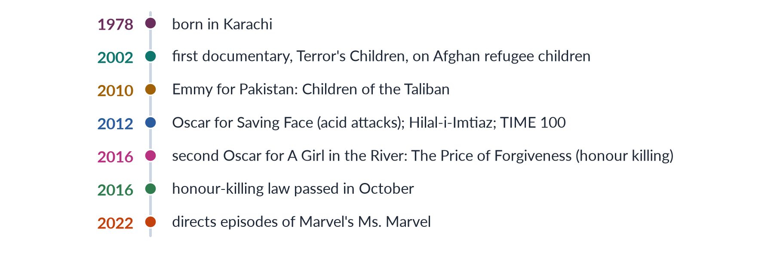
Figure 27 · Sharmeen Obaid-Chinoy's career.
Her company, SOC Films, has made more than a dozen films. She also co-directed Pakistan's first animated feature, 3 Bahadur (2015), and founded projects for children's education and for women's safety.

12.2 The first Oscar — *Saving Face* (2012)

(1) Background: acid attacks in Pakistan
Acid attacks — throwing acid, usually on a woman's face — were a growing crime in the 2000s, especially in southern Punjab, where acid used in cotton processing was cheap and easy to buy. Attacks were often revenge for refusing a marriage proposal or sexual advances, or arose from domestic and family disputes. Victims were left blind, disfigured and isolated; perpetrators were rarely punished.

(2) The film
Saving Face (2012), co-directed with the American filmmaker Daniel Junge, follows the British-Pakistani plastic surgeon Dr Mohammad Jawad, who returned to Pakistan to perform reconstructive surgery on acid-attack survivors. It tells the stories of two women — Zakia, attacked by her husband, who seeks justice in court, and Rukhsana, attacked by her husband and in-laws, who has to return to live with them because she has nowhere else to go. It also shows the work of activists and the legislators who pushed for a law.

(3) The award and impact
Saving Face won the Academy Award for Best Documentary (Short Subject) in February 2012 — Pakistan's first Oscar. The film coincided with the passage of the Acid Control and Acid Crime Prevention Act 2011, which made acid attacks punishable by 14 years to life imprisonment and a minimum fine of one million rupees. The government awarded her the Hilal-i-Imtiaz (2012), and TIME named her among the world's 100 most influential people.

12.3 The second Oscar — *A Girl in the River* (2016)

(1) Background: honour killing in Pakistan
Hundreds of women are killed each year in the name of honour (Chapter 6). The law allowed the victim's heirs — usually the killer's own family — to forgive the killer under the Qisas and Diyat law, so killers often walked free. A bill to close this loophole, moved by Senator Sughra Imam in 2014, had stalled.

(2) The film
A Girl in the River: The Price of Forgiveness (2015) tells the story of Saba Qaiser, 19, from a village near Gujranwala, Punjab. In 2014 she married the man she loved, against her family's wishes. Her father and uncle shot her in the face, put her in a sack and threw her into a river. She survived and dragged herself to the bank. The film follows her recovery and her struggle for justice — and her eventual decision, under heavy pressure from community elders, to forgive her father and uncle, who were then released. Her father declared in the film that he had done the right thing.

(3) The award and impact
The film won the Academy Award for Best Documentary (Short Subject) in February 2016. Prime Minister Nawaz Sharif hosted a screening at his office and declared, "There is no honour in honour killing", promising to change the law. After the murder of Qandeel Baloch in July 2016, Parliament passed the Criminal Law (Amendment) (Offences in the name or pretext of Honour) Act in October 2016, requiring life imprisonment even when the family forgives. The film was also shown on HBO and won an Emmy.
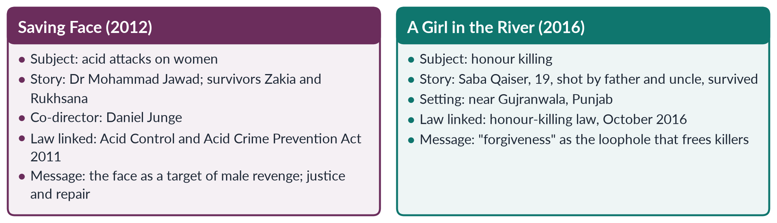
Figure 28 · Sharmeen Obaid-Chinoy's two Oscar-winning documentaries.

12.4 Common themes
1. Violence against women as a social, not private, problem.
2. Impunity — both films show how families and communities protect perpetrators.
3. Survivors' agency — women who resist, seek justice and rebuild their lives.
4. Film as advocacy — documentaries timed and used to push for law reform.
5. Pakistan's two faces — cruelty, but also doctors, lawyers, activists and legislators working for change.

12.5 Criticism and debate
- "Washing dirty linen in public": some critics in Pakistan accused her of tarnishing the country's image abroad by highlighting its worst problems for Western audiences.
- Representation: others argued that such films risk portraying Pakistani women only as victims and Pakistani men only as perpetrators.
- Defence: supporters reply that silence protects abusers; her films show survivors' courage and Pakistani reformers, and they helped change laws. She herself has said her aim is to provoke debate at home.
BALANCED VIEW · EVALUATING HER CONTRIBUTION
• Achievements: two Oscars and international recognition; global attention to acid attacks and honour killings; contribution to the 2011 and 2016 laws; inspiration for Pakistani filmmakers and women.
• Limits: laws alone did not end acid attacks or honour killings; Saba Qaiser still had to "forgive" her attackers; critics question the focus on negative images.
➜ Line to take: Sharmeen Obaid-Chinoy shows the power of media and storytelling in the fight against GBV — turning hidden crimes into national debates and pushing the state to act — while her films' own stories show that enforcement and social change must follow law reform.

12.6 The three case studies compared
Table 10 · The three case studies compared.
Aspect | Mukhtaran Mai | Malala Yousafzai | Sharmeen Obaid-Chinoy
Role | Survivor and activist | Education activist, Nobel laureate | Filmmaker and advocate
Violence | Gang rape ordered by a panchayat (2002) | Shot by the Taliban (2012) | Films on acid attacks and honour killing
Type of violence | Direct, structural and cultural; "honour" revenge | Political and religious extremism against girls' education | Domestic and honour-based violence
Response | Schools in Meerwala; women's organisation | UN speech, Malala Fund, Nobel Prize (2014) | Two Oscars (2012, 2016); law reform
Legal link | Debate behind the 2006 Act | Article 25A; girls' education policy | Acid Act 2011; honour law 2016
Criticism | State worried about its image | "Western agent"; "I am not Malala" | "Defames Pakistan abroad"
Lesson | Courage against structural injustice | Education as resistance | Media as a tool for change

EXAMINER'S EYE · THE MODEL STRUCTURE FOR 2020
1. Introduction: who she is; first Pakistani Oscar winner. 2. Background of Saving Face: acid attacks in Pakistan; the film; Dr Jawad, Zakia, Rukhsana; the Oscar (2012); the Acid Act 2011. 3. Background of A Girl in the River: honour killing and the forgiveness loophole; Saba Qaiser; the Oscar (2016); Nawaz Sharif; the October 2016 law. 4. Common themes. 5. Criticism and evaluation. 6. Conclusion. Draw the comparison figure.

Part Two — Today's Debates
Topic 7 questions ask you to judge and devise: which strategies are workable, whether laws work, what masculinity studies adds. Each debate below gives you the facts, both sides and a line to take.

Debate 1 · More laws, or better enforcement?
Pakistan has passed many laws since 2006: harassment (2010), acid and anti-women practices (2011), provincial domestic-violence laws (2013–2025), honour killing and rape (2016), the Anti-Rape Act (2021). Yet conviction rates in 2024 were about 0.5% for rape and honour killing (SSDO).
- For more laws: gaps remain — marital rape is not clearly recognised; forced conversion is not a specific crime nationally; child marriage at 16 survives in most provinces; honour killings can still be compounded if re-labelled.
- For enforcement: the main problem is police refusal, poor investigation, slow courts, pressured settlements and lack of shelters.
- Line to take: close a few specific gaps, but put most effort into enforcement — FIR registration, forensic capacity, special courts, witness protection and services in every district.

Debate 2 · Mediation and reconciliation — help or harm?
The Punjab Act 2016 allows Protection Centres and committees to try mediation and reconciliation.
- For: many women want the violence to stop, not the marriage to end; mediation is quick, cheap and culturally familiar.
- Against: in an unequal relationship, "reconciliation" can pressure women back into danger; families use it to avoid prosecution.
- Line to take: mediation only with the woman's free consent, never for serious violence, and with safety checks and follow-up.

Debate 3 · Is the family-forgiveness loophole really closed?
The 2016 law requires life imprisonment for honour killings even after forgiveness.
- Optimists: more prosecutions, greater awareness, a clear signal from Parliament.
- Sceptics: courts must first find that the killing was "for honour"; families claim other motives; the Qandeel Baloch acquittal (2022) showed that pardons still free killers.
- Line to take: make all GBV-related murders non-compoundable and train courts to recognise honour motives.

Debate 4 · The GPS bracelet and "Western" law
The Punjab Act's GPS tracker provision and its recognition of psychological and economic abuse drew charges from the Council of Islamic Ideology and religious parties that the law was "un-Islamic" and would destroy families.
- Defenders: Islam forbids cruelty and injustice; protecting women from violence protects families.
- Line to take: frame protection laws in Islamic and constitutional terms (Articles 9, 14, 25, 35) and work with scholars — opposition weakens when laws are seen as protecting families.

Debate 5 · Engaging men — or centring women?
Masculinity studies and programmes such as Rozan's urge work with men and boys.
- For: men commit most violence; changing masculinity is the only way to prevent it.
- Against: money and attention may shift away from women survivors.
- Line to take: do both — protect women now and change men for the future.

Debate 6 · Media and the "image" of Pakistan
Mukhtaran Mai, Malala and Sharmeen Obaid-Chinoy were all accused of "defaming" Pakistan abroad.
- Critics: foreign attention to Pakistan's worst cases distorts its image and serves outside agendas.
- Defenders: silence protects abusers; global attention forced reforms (2006, 2011, 2016).
- Line to take: the problem is the violence, not its exposure; Pakistan's image is improved by justice, not silence.

Debate 7 · Social media — new danger or new tool?
- Danger: cyber-harassment, blackmail, and "honour" violence against women who post online (Qandeel Baloch 2016; Sana Yousaf 2025).
- Tool: viral videos forced action in the Degari killings (Balochistan, 2025); online campaigns and helplines support survivors.
- Line to take: strengthen PECA enforcement against abusers while protecting women's online freedom.

Part Three — The Examiner's Record of Topic 7

Every question, 2016–2026
Table 11 · Every question the examiner has set on T7, 2016–2026.
Year · Q | The question (as set) | Family
2016 · Q3 | What are the sites and forms of violence against women in Pakistan and how in your view this menace can be eliminated from our society? | GBV — forms, sites and strategies to eliminate it
2017 · Q3 | What are the different forms of gender-based violence and, in your opinion, what could be the workable strategies to eliminate gender-based violence from Pakistani society? | GBV — forms, sites and strategies to eliminate it
2017 · Q8(a) | Short note: Honour killing | Honour killing
2018 · Q8(c) | Short note: Government initiatives for combating violence against women | GBV — laws and state initiatives
2019 · Q7 | Explain the structural and direct forms of violence against women in Pakistani society by highlighting the case study of Mukhtaran Mai. | GBV — forms, sites and strategies to eliminate it; Case study — Mukhtaran Mai
2020 · Q7 | Comment on the power-and-control relationship in gender-based violence. | GBV — causes, theories, power and control
2020 · Q8 | Discuss the background of the two Oscar-winning documentaries by Sharmeen Obaid-Chinoy. | Case study — Sharmeen Obaid-Chinoy
2023 · Q8 | Define gender-based violence. Explain various forms of violence against women in Pakistan and devise practical strategies helpful in eradicating gender-based violence from our society. | GBV — forms, sites and strategies to eliminate it
2024 · Q6 | What is gender-based violence? What forms of gender-based violence are given in the Punjab Protection of Women Against Violence Act 2016? What are the consequences of gender-based violence for women? | GBV — laws and state initiatives; GBV — forms, sites and strategies to eliminate it
2025 · Q2 | What are the root causes that lead to gender-based violence? How do these factors intersect and perpetuate violence against women in Pakistan? | GBV — causes, theories, power and control
2025 · Q8 | Critically examine and evaluate Malala Yousafzai's achievements and activism for promoting girls' education in local and global contexts. | Case study — Malala Yousafzai
2026 · Q8(b) | Short note: The role of masculinity studies in understanding violence against women in Pakistani society | Masculinities and violence against women

What the record reveals
- Nine full questions and three short notes (10.5 visits), and 12 of the 140 MCQs — one of the heaviest topics, after Topics 4 and 1.
- Forms and strategies are asked again and again: 2016 (sites and forms; how to eliminate), 2017 (forms; workable strategies) and 2023 (define; forms; practical strategies) — three near repeats. 2024 added the Punjab Act 2016 and consequences.
- Theory is rising: power and control (2020), root causes and how they intersect (2025) and masculinity studies (2026 note).
- Each case study has been asked once: Mukhtaran Mai with structural and direct violence (2019), Sharmeen Obaid-Chinoy's two documentaries (2020), and Malala's achievements (2025).
- Short notes: honour killing (2017), government initiatives (2018), masculinities (2026).
- Never yet asked in full: acid attacks; workplace harassment; cyber violence; the cycle of violence; the ecological model; a comparison of the three case studies.

Five likely questions
1. "Critically evaluate the effectiveness of laws against gender-based violence in Pakistan. Why do conviction rates remain so low?" (Chapters 4 and 7.)
2. "Explain the ecological model of violence against women and apply it to Pakistan." (Chapters 2 and 4.)
3. "What do the lives of Mukhtaran Mai, Malala Yousafzai and Sharmeen Obaid-Chinoy teach us about resisting gender-based violence in Pakistan?" (Chapters 10–12.)
4. "Discuss workplace sexual harassment in Pakistan and evaluate the Protection against Harassment of Women at the Workplace Act 2010." (Chapters 5 and 7.)
5. "Cyber violence is the new frontier of gender-based violence. Discuss with reference to Pakistan." (Chapter 5.)
These are not solved here; the Prediction Papers include answers to predicted questions. Plan each as an answer map for practice.

Part Four — The One-Liner Bank
About 125 one-liners in the style of the past MCQs. Each is a complete, checkable fact: the key word is in bold green and the date in bold navy. Read them aloud; cover the bold words and test yourself; then attempt every past MCQ below.

The one-liners

A · Defining gender-based violence
1. Gender-based violence is violence directed at a person because of their sex or gender (MCQ 2025).
2. The UN Declaration on the Elimination of Violence against Women (DEVAW) was adopted on 20 December 1993.
3. DEVAW Article 1 covers physical, sexual and psychological harm, including threats, coercion and deprivation of liberty, in public or private life.
4. DEVAW Article 2 names three sites: the family, the community and the State.
5. The Vienna World Conference on Human Rights (1993) declared women's rights to be human rights.
6. CEDAW General Recommendation 19 (1992) declared gender-based violence a form of discrimination.
7. CEDAW General Recommendation 35 (2017) updated GR 19.
8. The Beijing Platform (1995) made violence against women Critical Area D.
9. 25 November is the International Day for the Elimination of Violence against Women (designated 1999).
10. The 16 Days of Activism run from 25 November to 10 December, Human Rights Day.
11. The Council of Europe's Istanbul Convention on violence against women was adopted in 2011.
12. SDG target 5.2 calls for eliminating all forms of violence against women and girls.
13. SDG target 5.3 calls for eliminating child, early and forced marriage.
14. About 1 in 3 women worldwide experience physical or sexual violence (WHO 2021; MCQ 2024).
15. About 85,000 women and girls were killed intentionally in 2023 (UNODC and UN Women).
16. About 51,100 of them were killed by partners or family members — one every 10 minutes.
17. Liz Kelly described violence against women as a continuum (1988).
18. The WHO calls violence against women a public health problem of epidemic proportions.
19. Economic abuse includes denying a woman food, clothing, shelter or her own income.
20. Femicide is the intentional killing of women and girls because they are women.

B · Theories of violence
21. Albert Bandura's Bobo doll experiments (1961) showed that children copy aggression.
22. Bandura's Aggression: A Social Learning Analysis appeared in 1973.
23. According to social learning theory, violence is learned (MCQ 2023) and socially constructed (MCQ 2024).
24. The passing of violence from parents to children is called intergenerational transmission.
25. William Goode (1971) proposed the resource theory of family violence.
26. R. Emerson Dobash and Russell Dobash wrote Violence Against Wives (1979).
27. Feminist theory sees patriarchy as the root cause of violence against women.
28. Susan Brownmiller wrote Against Our Will (1975), arguing that rape is about power.
29. Lenore Walker described the cycle of violence in The Battered Woman (1979).
30. Walker's cycle has phases of tension building, acute battering and loving contrition.
31. Walker also described "learned helplessness" among battered women.
32. The Power and Control Wheel was developed by the Domestic Abuse Intervention Project in Duluth, Minnesota (from 1981).
33. Ellen Pence and Michael Paymar were leading figures of the Duluth model.
34. The hub of the Duluth wheel is power and control; its rim is physical and sexual violence.
35. Evan Stark wrote Coercive Control (2007).
36. Michael Johnson distinguished intimate terrorism from situational couple violence.
37. Lori Heise proposed the ecological model of violence against women (1998).
38. Heise's four levels are individual, relationship, community and society.
39. Johan Galtung defined structural violence in 1969.
40. Galtung added cultural violence in 1990.
41. Direct violence has an identifiable perpetrator; structural violence is built into social structures.
42. Kimberlé Crenshaw's "Mapping the Margins" (1991) applied intersectionality to violence against women.

C · Masculinities
43. R. W. Connell introduced hegemonic masculinity (Gender and Power 1987; Masculinities 1995).
44. The patriarchal dividend is the advantage men gain from women's subordination (Connell).
45. Connell's hierarchy: hegemonic, complicit, marginalised and subordinated masculinities.
46. Michael Kaufman described the triad of men's violence (1987).
47. Kaufman's triad: violence against women, against other men, and against themselves.
48. Michael Kimmel described "aggrieved entitlement".
49. Rozan, an Islamabad NGO founded in 1998, works with boys, men and police on gender and violence.
50. The White Ribbon Campaign of men against violence began in Canada in 1991.
51. UN Women launched the HeForShe campaign in 2014.
52. Ghairat and izzat are the Pakistani concepts of male honour linked to women's behaviour.

D · Forms and data in Pakistan
53. 28% of ever-married women in Pakistan have experienced physical violence since age 15 (PDHS 2017–18).
54. 34% of ever-married women have experienced spousal physical, sexual or emotional violence (PDHS 2017–18).
55. 56% of women who suffered violence never sought help (PDHS 2017–18).
56. SSDO recorded 32,617 gender-based violence cases in 2024.
57. SSDO recorded 5,339 rape cases in 2024.
58. SSDO recorded 547 honour killings in 2024.
59. Conviction rates in 2024 were about 0.5% for rape and honour killing (SSDO).
60. HRCP recorded at least 405 honour killings in 2024.
61. Karo-kari is the Sindhi term for honour killing.
62. Siyahkari is the Balochi term; tor tora the Pashto term; kala kali the Punjabi term.
63. Vani or swara is giving girls in marriage to settle a dispute.
64. Watta satta is exchange marriage.
65. Stove burning is the killing or burning of women disguised as kitchen accidents.
66. Six-year-old Zainab Ansari was raped and murdered in Kasur in 2018.
67. The motorway gang rape near Lahore took place in September 2020.
68. Noor Mukadam was murdered in Islamabad in 2021; the Supreme Court upheld her killer's death sentence in 2025.
69. Sana Yousaf, a 17-year-old social-media creator, was shot dead in Islamabad in June 2025.
70. A couple were killed on a tribal chief's orders in Degari, Balochistan, in 2025.
71. Samia Sarwar was killed in her lawyers' Lahore office in 1999.
72. Qandeel Baloch was killed by her brother in Multan in July 2016.
73. Qandeel Baloch's brother was acquitted by the Lahore High Court in 2022 after a parental pardon.

E · Laws
74. The Zina Ordinance of 1979 endangered rape victims with adultery charges.
75. The Qisas and Diyat Ordinance (1990) let victims' heirs forgive killers.
76. The Criminal Law (Amendment) Act 2004 defined honour crimes.
77. The Protection of Women (Criminal Laws Amendment) Act 2006 moved rape back into the Penal Code.
78. The Protection against Harassment of Women at the Workplace Act was passed in 2010.
79. The workplace harassment law was amended in 2022 to cover more workers.
80. Section 509 PPC punishes harassment in public places (amended 2010).
81. The Acid Control and Acid Crime Prevention Act was passed in 2011.
82. The Acid Act added sections 336A and 336B to the Penal Code.
83. Acid attacks carry 14 years to life imprisonment and a minimum fine of one million rupees.
84. The Prevention of Anti-Women Practices Act was passed in 2011.
85. Section 310A PPC punishes giving a woman in vani or swara.
86. Section 498B PPC punishes forced marriage; 498C marriage to the Qur'an; 498A denial of inheritance.
87. Sindh passed the first provincial domestic-violence law in 2013.
88. Balochistan passed its domestic-violence law in 2014.
89. Khyber Pakhtunkhwa passed its domestic-violence law in 2021.
90. Islamabad's Domestic Violence (Prevention and Protection) Act was passed in 2025.
91. The Criminal Law (Amendment) Act 2016 restricted the family-forgiveness loophole in honour killings (MCQ 2026).
92. The 2016 honour law requires life imprisonment even if the family forgives.
93. Senator Sughra Imam moved the anti-honour-killing bill in 2014.
94. The 2016 anti-rape amendment required DNA testing.
95. The Prevention of Electronic Crimes Act (PECA) was passed in 2016.
96. The Zainab Alert, Response and Recovery Act was passed in 2020.
97. The Anti-Rape (Investigation and Trial) Act received assent on 1 December 2021.
98. The 2021 Act created Special Sexual Offences Investigation Units and Anti-Rape Crisis Cells.
99. The Prevention of Trafficking in Persons Act was passed in 2018.

F · The Punjab Act 2016 and institutions
100. The Punjab Protection of Women against Violence Act was passed on 24 February 2016.
101. Its section 2(r) lists domestic violence, sexual violence, psychological abuse, economic abuse, stalking and cybercrime.
102. Complaints under the Punjab Act go to the Family Court, which must decide within 90 days.
103. The Act provides interim, protection, residence and monetary orders.
104. A protection order may require a GPS ankle or wrist bracelet for grave violence.
105. Breach of an order is punishable by up to one year; repeat breach by up to two years.
106. A false complaint is punishable by up to three months or a fine.
107. The Act created District Women Protection Committees and Women Protection Officers.
108. The first Violence against Women Centre opened in Multan in 2017.
109. The Punjab Women Helpline number is 1043.
110. The first women's police stations opened in 1994.
111. The National Commission on the Status of Women was set up in 2000 (Act 2012).
112. Dar-ul-Aman are government shelters for women.

G · The case studies
113. Mukhtaran Mai was gang-raped on a panchayat's orders in Meerwala, Muzaffargarh, on 22 June 2002.
114. Mukhtaran Mai belonged to South Punjab (MCQ 2016).
115. The Supreme Court upheld the acquittal of five accused in the Mukhtaran Mai case on 21 April 2011.
116. Mukhtaran Mai's memoir is In the Name of Honor (2006).
117. Malala Yousafzai was born on 12 July 1997 in Mingora, Swat (MCQ 2016).
118. Malala wrote a BBC Urdu diary as "Gul Makai" in 2009.
119. Malala was shot by the Taliban on 9 October 2012.
120. Malala addressed the United Nations on 12 July 2013 — "Malala Day".
121. Malala shared the Nobel Peace Prize with Kailash Satyarthi in 2014, at 17.
122. Malala works internationally for girls' education (MCQ 2019).
123. Sharmeen Obaid-Chinoy is a filmmaker (MCQ 2025), born in Karachi in 1978.
124. Saving Face (Oscar 2012) is about acid attacks; co-directed with Daniel Junge.
125. A Girl in the River (Oscar 2016) is about honour killing and Saba Qaiser (MCQ 2019).

Every past MCQ on Topic 7
Table 12 · Every recovered MCQ on T7, with its key.
Year | Question | Key
2016 · 3 | Malala Yousafzai was born in: | D - 1997
2016 · 19 | Mukhtaran Mai belonged to: | A - South Punjab
2019 · 9 | Malala Yousafzai works internationally for women's: | A - Education
2019 · 16 | A Girl in the River was about: | A - Honour killing
2023 · 1 | Which statement regarding sexual harassment is incorrect? | B - Demand work
2023 · 6 | Which term is not clearly associated with violence? | A - Adultery
2023 · 15 | Domestic violence is: | A - Learned behaviour
2024 · 12 | How many women worldwide face gender-based violence? | C - 1 out of 3
2024 · 14 | According to social learning theory, violence against women is: | A - Socially constructed
2025 · 17 | Gender-based violence is: | D - Violence based on sex or gender
2025 · 18 | Sharmeen Obaid-Chinoy is famous as a: | B - Filmmaker
2026 · 13 | Which Pakistani legislation criminalized honour killings and restricted the family-forgiveness loophole? | A - Criminal Law (Amendment) Act 2016

TRAP · THREE MCQ TRAPS IN TOPIC 7
1. Honour law: 2004 or 2016? The 2004 Act defined honour crimes and raised penalties; the 2016 Act restricted the forgiveness loophole with a mandatory life sentence (MCQ 2026). Read which one the stem describes.
2. "Learned" and "socially constructed". Social learning theory says violence is learned (MCQ 2023) and socially constructed (MCQ 2024) — not biological or innate.
3. The two Oscars. Saving Face (2012) is about acid attacks; A Girl in the River (2016) is about honour killing (MCQ 2019). Do not swap them.

Part Five — The Revision Sheet
The whole of Topic 7 in a few pages, for the night before the exam. Every term is explained where it appears, so you will not need to turn back to the chapters.

1. Defining gender-based violence (2017, 2023, 2024)
- Violence (WHO 2002) — intentional use of physical force or power, threatened or actual, causing or likely to cause injury, death, psychological harm, maldevelopment or deprivation.
- Gender-based violence (GBV) — harm directed at a person because of their gender, rooted in gender inequality, abuse of power and harmful norms (UNHCR, UN Women); physical, sexual, psychological, economic; threats included; public or private life. MCQ 2025: violence based on sex or gender. Falls mainly on women and girls; can also target men, boys and sexual minorities.
- DEVAW (UN General Assembly, 20 Dec 1993) — Art. 1: "any act of gender-based violence that results in, or is likely to result in, physical, sexual or psychological harm or suffering to women, including threats of such acts, coercion or arbitrary deprivation of liberty, whether occurring in public or in private life". Art. 2: three sites — family (battering, sexual abuse of girls, dowry violence, marital rape, harmful traditional practices), community (rape, harassment at work and in schools, trafficking, forced prostitution), State (perpetrated or condoned).
- Milestones — CEDAW 1979 (silent on violence) → GR 19 (1992): GBV is discrimination → Vienna 1993 ("women's rights are human rights") → DEVAW 1993 → UN Special Rapporteur and Belém do Pará (1994) → Beijing 1995, Critical Area D → 25 November designated 1999; 16 Days of Activism (25 Nov–10 Dec) → UNSCR 1325 (2000) → Istanbul Convention 2011 (prevention, protection, prosecution, integrated policies) → SDG 5.2 (end violence) and 5.3 (end child marriage, 2015) → GR 35 (2017).
- Scale — WHO 2021: about 1 in 3 women (≈736 million) experience physical or sexual violence (MCQ 2024). UNODC/UN Women 2024: 85,000 women and girls killed intentionally in 2023; 51,100 (60%) by partners or family — 140 a day, one every 10 minutes.
- Pakistan — PDHS 2017–18: 28% of ever-married women physical violence since 15; 6% sexual; 34% spousal physical, sexual or emotional; 56% never sought help. SSDO 2024: 32,617 GBV cases (kidnapping 24,439; rape 5,339; domestic violence 2,238; honour killing 547); conviction ≈ 0.5% rape and honour, 1.3% DV, 0.1% kidnapping. HRCP 2024: 405 honour killings; 3,300+ beatings; 14,425 cases documented.
- Punjab Act 2016, s. 2(r) — "violence" = any offence against the body of the aggrieved person incl. abetment, domestic violence, sexual violence, psychological abuse, economic abuse, stalking, cybercrime.
- Classify GBV — by nature (physical, sexual, psychological, economic); by site (home, community/workplace, public spaces, online, state/custody); by perpetrator (partner, family, acquaintance, stranger, state); by life cycle (sex selection → neglect of girls, child abuse → child marriage, vani, harassment → DV, marital rape, honour killing, acid, dowry → neglect of widows, denial of inheritance).
- Continuum — Liz Kelly (Surviving Sexual Violence, 1988): everyday harassment to rape and femicide are connected by men's power and women's fear.
- Why it matters — human rights (Arts 9, 14, 25), public health ("epidemic proportions", WHO), development (SDG 5; costs ≈ 2% of world GDP), democracy (fear keeps women out of public life).
- GBV or VAW? — define GBV; explain it falls mainly on women; use DEVAW for VAW.

2. Theories of violence against women (2020, 2025)
- Biological — testosterone, evolution, mate-guarding. Critique: ignores variation across countries and time; most men non-violent; abusers control violence elsewhere; excuses violence.
- Psychological — personality, anger, mental illness, alcohol and drugs, childhood trauma. Critique: most abusers not ill; violence planned and selective; alcohol a trigger, not cause; victim-blaming ("provocation").
- Social learning — Albert Bandura: Bobo doll experiments (1961), Aggression: A Social Learning Analysis (1973); violence learned by observing and when rewarded/unpunished; intergenerational transmission (sons copy fathers, daughters accept); media models. MCQs: domestic violence is learned behaviour (2023); violence is socially constructed (2024). Critique: many from violent homes are not violent; does not explain why men target women. PDHS: large shares of women and men say wife-beating justified for some reason.
- Resource and exchange — William Goode (1971): force is a resource used when others (money, status) fail; exchange: violence when rewards exceed costs (no police, no sanction). Explains job loss, wives earning more, low costs. Critique: rich men abuse; does not explain male entitlement.
- Feminist — Dobash and Dobash, Violence Against Wives (1979): wife-beating = expression of male authority and entitlement, supported by law, religion, custom; patriarchy the root; violence functional (keeps women subordinate); "the personal is political"; institutions complicit. Susan Brownmiller, Against Our Will (1975): rape keeps "all women in a state of fear" — power, not sex. Critique: may overlook women's violence, same-sex violence, class and race; Crenshaw, "Mapping the Margins" (1991) — intersectionality.
- Power and control — Duluth wheel (Domestic Abuse Intervention Project, 1981; Ellen Pence, Michael Paymar): hub power and control; spokes intimidation, emotional abuse, isolation, minimising/denying/blaming, using children, male privilege, economic abuse, coercion and threats; rim physical and sexual violence; "co-ordinated community response".
- Cycle of violence — Lenore Walker, The Battered Woman (1979): tension building → acute battering → loving contrition ("honeymoon") → repeat; explains why women stay; "learned helplessness" (criticised).
- Coercive control — Evan Stark (2007): pattern of isolation, intimidation, surveillance, degradation; like a hostage; crime in England and Wales (2015). Michael Johnson (1995, 2008): intimate terrorism (control, mostly men) vs situational couple violence (both sexes, less severe).
- Ecological model — Lori Heise (1998), adopted by WHO: individual (witnessed violence, alcohol, low education) → relationship (male control of money and decisions, conflict, dowry) → community (poverty, jirgas, isolation, peer approval) → society (male entitlement, honour norms, acceptance of violence, impunity).
- Galtung — direct (visible, a perpetrator), structural (1969: built into structures; "social injustice"; potential below actual), cultural (1990: beliefs that legitimise the other two).
- Line — ecological, feminist approach: patriarchal norms and impunity (society), jirgas (community), learned behaviour and economic stress (relationship, individual).

3. Power and control (2020)
- Instrumental violence — not just anger; a way to get and keep control over movement, money, friends, sexuality, marriage, thoughts; the threat governs life even without frequent beatings.
- Pakistani tactics — intimidation (threats of talaq or second marriage; smashing goods); emotional abuse (taunts about dowry, sons, her family); isolation (no visits to parents, phone taken, purdah as control); minimising/blaming ("a husband may discipline"); using children (custody threats); male privilege (husband and in-laws decide work, school, health, contraception); economic abuse (salary or dowry taken, inheritance denied, no paid work); coercion and threats (acid, honour killing, harm to family).
- Punjab Act 2016 recognises economic and psychological abuse, stalking and cybercrime — not only assault.
- Commenting — strengths: explains selective, patterned, gendered violence; non-physical abuse is real; fits honour killing, acid, forced marriage (punishing choice); guides practice (Duluth model, perpetrator programmes). Limits: focus on intimate partners; may underplay alcohol, illness, poverty; mixed results of programmes; misses situational violence. Line: best single explanation, inside an ecological frame.

4. Structural and direct violence; Mukhtaran Mai (2019)
- Direct — beating, rape and gang rape, acid, honour killing, stove burning, harassment, forced marriage, abduction; 32,617 reported cases (2024).
- Structural — female literacy ≈53%; MMR 186; LFPR 24.4%; denial of inheritance; laws that let honour killers be pardoned (before 2016); Hudood 1979 (rape victims risked zina charges); slow courts, ≈0.5% convictions; jirgas; police refusal.
- Cultural — honour (izzat, ghairat) in women's bodies; husband may "discipline"; daughters as paraya dhan; misused religion; dramas romanticising control.
- Vicious circle — cultural beliefs justify structural arrangements → vulnerability to direct violence → impunity confirms beliefs.
- Mukhtaran Mai — direct (gang rape on panchayat order), structural (clan hierarchy, parallel justice, slow courts, acquittals, poverty), cultural (woman as honour debt; silence or suicide expected; victim-blaming).

5. Root causes and how they intersect (2025)
- Root cause vs trigger — root causes (patriarchy, inequality, impunity) explain why violence is common and gendered; triggers (dowry quarrel, unemployment, drugs, a daughter's choice) explain when.
- Patriarchy — male authority and guardianship; honour; son preference; control of sexuality and marriage (forced marriage, watta satta); Saima Waheed (SC 2004): adult woman may marry without wali.
- Economic dependence — LFPR 24.4%; little land or inheritance (Property Rights Act 2020); cannot leave; poverty, unemployment and dowry raise tensions (resource theory).
- Impunity — SSDO 2024: rape 0.5%, honour 0.5%, DV 1.3%, kidnapping 0.1%; Punjab 225 honour killings, 2 convictions; Sindh 0 convictions for rape and honour; FIR refusal; poor forensics; witness pressure; slow trials; pardons (Qandeel Baloch acquittal 2022).
- Customs and parallel justice — jirgas and panchayats order vani, swara, kari killings, punishment rape (Mukhtaran Mai); Supreme Court declared rights-violating jirgas illegal; Anti-Women Practices Act 2011.
- Ideas — low literacy and awareness; misinterpreted religion (mainstream scholars reject honour killing); media stereotypes; social media triggers.
- Crisis — militancy (Malala 2012; schools destroyed), displacement, 2022 floods, COVID-19 lockdowns (2020).
- Intersection of causes — norms × economy (honour keeps women home; dependence keeps them silent); economy × law (poor women cannot afford justice; rich abusers buy settlements); law × custom (where courts fail, jirgas rule); ideas × institutions (police see "family matters" as private).
- Intersection of identities — rural and poor women; Hindu and Christian girls (abduction, forced conversion and marriage, Sindh and Punjab); women with disabilities; child domestic workers; khawaja siras (despite the Transgender Act 2018).
- Ecological levels — society, community, relationship, individual; strategies at all four.
- Line — patriarchy is the root; impunity and economic dependence keep it producing violence; attack norms, independence and justice together.

6. Sites and forms in Pakistan (2016, 2017, 2023)
- Sites — home (most dangerous: DV, marital rape, honour killing, dowry, stove burning); community (jirgas, vani/swara, rape, acid, abduction); workplace (harassment; domestic and home-based workers); public spaces and transport (street harassment, stalking); online (cyber-harassment, blackmail, image abuse); state and custody (custodial abuse, police inaction, discriminatory laws).
- Domestic violence — beating, burning, starvation, marital rape, threats, confinement, economic abuse; dowry violence (Dowry and Bridal Gifts Act 1976 unenforced); stove burning; DV laws Sindh 2013, Balochistan 2014, Punjab 2016, KP 2021, ICT 2025.
- Rape — 5,339 cases (2024), 0.5% conviction; gang rape as punishment; Zainab Ansari (Kasur, Jan 2018) → Zainab Alert Act 2020; motorway gang rape (Sept 2020; victim-blaming by a senior officer) → Anti-Rape Act 2021; Zina Ordinance 1979 → 2006 Act → 2016 DNA amendment.
- Acid attacks — revenge for refused proposals or advances, family disputes; blindness, disfigurement, isolation; Acid Act 2011 (ss. 336A, 336B; 14 years to life, fine ≥ Rs 1 million); Saving Face (2012).
- Harassment — workplace (2010 Act; inquiry committees, code of conduct, ombudspersons; amended 2022); public (s. 509 PPC, 2010); education; MCQ 2023.
- Custom-based — vani/swara (s. 310A), denial of inheritance (498A), forced marriage (498B), marriage to the Qur'an (498C) — Anti-Women Practices Act 2011; watta satta; child marriage (1929 Act; Sindh 2013 and ICT 2025 = 18).
- Forced conversion of Hindu and Christian girls — abduction, conversion, marriage to older men; no national law yet.
- Trafficking and abduction — 24,439 kidnapping cases (2024; some filed against daughters who marry by choice); Trafficking in Persons Act 2018.
- Cyber violence — PECA 2016 (ss. 20–21 dignity and modesty; 24 cyber-stalking); Digital Rights Foundation helpline (2016); Qandeel Baloch (2016); Sana Yousaf (17, Islamabad, 2 June 2025, after refusing advances).
- State violence — custodial abuse, police refusal, discriminatory laws (Hudood; old Qisas and Diyat pardons).
- Answering — group by site or nature; data for three forms; a law for each; two or three cases.

7. Honour killing (2017 note)
- Definition — murder of a woman (sometimes a man) by family or community claiming she brought shame; "offences": choosing a husband, divorce, relationships, being raped, talking to a man, refusing marriage, "immodesty", social media.
- Names — karo-kari (Sindh), siyahkari (Balochistan), tor tora (KP), kala kali (Punjab).
- Scale — HRCP 405 (2024); SSDO 547 (2024), ≈0.5% convictions; Punjab 225 → 2 convictions; hidden as suicide or accident.
- Causes — honour and patriarchy (cultural violence); control of marriage and property; false karo-kari accusations to grab land or settle disputes; community pressure (be-ghairat); jirga approval; impunity; misused religion (CII and scholars condemn).
- Law — PPC 1860 "grave and sudden provocation"; Qisas and Diyat Ordinance 1990 (Act 1997): murder compoundable; heirs (often the killers' family) forgive; 2004 Criminal Law (Amendment) Act: honour crimes defined, penalties raised, loophole open; 2016 Criminal Law (Amendment) (Offences in the name or pretext of Honour) Act (joint sitting, October 2016): heirs may forgive qisas but court must award life imprisonment (25 years) as ta'zir — MCQ 2026; bill moved by Sughra Imam (2014). Weakness: motive must be proved; re-labelling; hostile witnesses.
- Cases — Samia Sarwar (1999, shot in lawyers' office — Hina Jilani and Asma Jahangir — mother present; family unpunished); Qandeel Baloch (strangled by brother Waseem, Multan, July 2016; life 2019; LHC acquittal Feb 2022 after parental pardon); Saba Qaiser (19, Gujranwala, 2014, shot by father and uncle, survived, "forgave" under pressure; A Girl in the River); Bano Satakzai and Ehsanullah Samalani (Degari, Balochistan, June 2025, tribal chief's orders; viral video July 2025; arrests).
- Strategies — fully non-compoundable; investigate every suspicious death; prosecute jirgas; shelters and protection for couples; scholars' statements; education and media; economic independence.
- Assessment — 2016 law necessary; impunity continues through settlements, weak investigation and social approval.

8. Laws, the Punjab Act 2016 and government initiatives (2018, 2024)
- Framework — Arts 9, 14, 25, 35, 37; CEDAW (1996), GR 19 and 35; Beijing Area D; ICCPR and CAT (2010); SDG 5.2/5.3; GSP+ (2014; 27 conventions).
- Main laws — 2006 Protection of Women Act (rape to PPC; end of four-witness rule; MCQ 2016); 2010 workplace harassment (+ s. 509); 2011 Acid; 2011 Anti-Women Practices; 2013–2025 provincial DV laws; 2016 honour; 2016 anti-rape (DNA, in-camera trials, penalties for obstructing police); 2016 PECA; 2018 Trafficking; 2020 Zainab Alert; 2020 Property Rights; 2021 Anti-Rape (Investigation and Trial) Act (assent 1 Dec 2021; Special Sexual Offences Investigation Units, Anti-Rape Crisis Cells, special courts, in-camera, ≈4 months, sex-offenders register); 2022 harassment amendment; 2025 ICT DV Act (Sharmila Farooqui; NA 13 Nov, Senate 28 Nov) and ICT child-marriage law (18).
- Punjab Act 2016 — passed 24 Feb 2016, gazetted 29 Feb; aim: "protection, relief and rehabilitation"; mainly civil. Forms (s. 2(r)): abetment, domestic violence (by a person she lives/lived with, related by blood, marriage or adoption), sexual violence, psychological abuse (oppressive behaviour or restricted movement causing depression, anorexia or suicide attempt, certified by a panel), economic abuse (denial of food, clothing, shelter; taking her income), stalking, cybercrime. Procedure: Family Court; first hearing within 7 days; decision within 90 days. Orders: interim (s. 6); protection (s. 7: no contact, stay away, distance, GPS bracelet for grave violence, move out, surrender weapons); residence (s. 8: no eviction, stay in house or shelter, rent for alternative accommodation); monetary (s. 9: compensation for economic abuse, lost earnings, medical costs, damage, maintenance). System: toll-free helpline (s. 3); District Women Protection Committees (s. 11); Protection Centres = Violence against Women Centres (s. 13: one-stop — FIR, medical, forensics within 24 hours, legal aid, counselling, mediation; first Multan 2017); shelter homes; Women Protection Officers (s. 14). Penalties: breach up to 1 year, Rs 50,000–200,000; repeat 1–2 years; false complaint up to 3 months or Rs 50,000–100,000. Reaction: praised as first to recognise economic and psychological abuse, stalking, cybercrime; CII and religious parties called it un-Islamic; mediation risks; slow implementation.
- Institutions — NCSW 2000 (Act 2012); provincial commissions; NCHR 2012; harassment ombudspersons (2010); women's police stations (1994); gender desks; VAWC Multan (2017); Punjab Women Protection Authority (2017); Anti-Rape Crisis Cells; Dar-ul-Aman shelters; helplines 1043 (Punjab women), 1099 (human rights), 15 (police); family courts; GBV courts (Punjab pilot 2017); special courts (2021); National Policy 2002; BISP 2008.
- Enforcement gap — low awareness; family pressure; FIR refusal; poor investigation and forensics; slow courts, hostile witnesses; ≈0.5% convictions; few shelters; uneven provinces after the 18th Amendment.

9. Consequences (2024)
- Physical — injury, disability, acid disfigurement, death (51,100 partner/family femicides worldwide, 2023).
- Sexual and reproductive — unwanted pregnancy, unsafe abortion, miscarriage, low birth weight, STIs/HIV, fistula, maternal death.
- Mental — depression (almost 2× risk, WHO), anxiety, PTSD, low self-esteem, substance use, suicide; Punjab Act's psychological violence.
- Economic — lost work and income, forbidden work, fear of harassment cuts participation (LFPR 24.4%), poverty after leaving.
- Children — trauma, poor schooling, intergenerational cycle; child marriage ends schooling.
- Society and development — fear limits public life and politics; costs ≈ 2% of world GDP; weak rule of law; SDGs 3, 4, 5, 8, 16.
- Silence — 56% never sought help (PDHS).

10. Strategies to eliminate GBV (2016, 2017, 2023)
- Principles — attack root causes; all ecological levels; survivor-centred; realistic.
- Framework — Istanbul's "four Ps" (prevention, protection, prosecution, policies) → Pakistani "five Ps": Prevention, Protection, Prosecution, Provision, Partnership.
- Prevention — gender equality and consent in schools; keep girls in school; engage men and boys (Rozan); religious scholars and khutbas; responsible media; women's economic empowerment (jobs, inheritance, BISP); 18-year marriage age and registration.
- Protection — 24-hour helplines (1043, 1099, DRF); enforce protection orders; dignified shelters; one-stop centres in every district; safe transport, lighting, CCTV, safe cities; protect couples and witnesses.
- Prosecution — compulsory FIRs and action against police who refuse; more women police; training; DNA labs and women medico-legal officers; special courts (2021 Act), fast in-camera trials; non-compoundable GBV crimes; act against jirgas.
- Provision — free legal aid, medical care, counselling, vocational training, economic support; local languages; rural, minority and disabled women.
- Partnership — co-ordinated community response (Duluth); national GBV database; funding; NGOs (Aurat Foundation, Shirkat Gah, Rozan, War Against Rape, Acid Survivors Foundation); provincial harmonisation.
- By level — society (laws, campaigns, scholars, economic rights); community (jirgas, mobilisation, transport, LHWs as first responders); relationship (registration, counselling, women's control of income); individual (girls' schooling, boys' life skills, perpetrator programmes, survivor support).
- Workable — quick wins (FIRs, special courts, helplines, centres) + long-term prevention (norms, masculinity).

11. Masculinities and violence (2026 note)
- Masculinity studies — how manhood is socially constructed and ranked; grew in the 1980s; masculinities, not one masculinity.
- Connell (Gender and Power 1987; Masculinities 1995) — hegemonic masculinity (honoured ideal legitimising male dominance), complicit, marginalised, subordinated; patriarchal dividend.
- How it explains violence — proof of manhood; ghairat before other men (honour killing); entitlement (acid attacks on women who refuse; Sana Yousaf 2025); emotional restriction (anger the only permitted emotion); "crisis of masculinity" under unemployment (resource theory); peer groups, jirgas, police, media.
- Kaufman (1987) — triad: violence against women, other men, themselves. Kimmel — "aggrieved entitlement" (Guyland 2008; Angry White Men 2013).
- Pakistan — provider/protector ideal; sons free, daughters obedient; possessive heroes in dramas; marginalised men assert power at home; khawaja siras and "effeminate" men targeted.
- Role — focuses on men; violence learned and changeable; explains honour violence and male silence; points to solutions.
- Practice — Rozan (1998), MenEngage, White Ribbon (1991), HeForShe (2014), scholars modelling non-violence, fathers like Ziauddin Yousafzai.
- Limits — risk of diverting resources; mixed programme results; must not excuse violence; adapt Western concepts. Line: essential, but complements women-centred protection.

12. Case study I — Mukhtaran Mai (2019)
- Background — Mukhtaran Bibi ("Mukhtar Mai"), Tatla (Gujjar) clan, Meerwala, Muzaffargarh, South Punjab (MCQ 2016); powerful Mastoi (Baloch) clan; uneducated, taught the Qur'an.
- Event — 22 June 2002: brother Shakoor (≈12) accused of a relationship with a Mastoi woman; Mastoi-dominated panchayat ordered gang rape of Mukhtaran Mai as "punishment"; raped by four men; made to walk home publicly.
- Breaking silence — refused silence or suicide; imam's sermon, local journalist, national and international media; case registered.
- Legal journey — ATC D.G. Khan, Aug 2002: 6 sentenced to death, 8 acquitted; LHC Multan bench, 2005: 5 acquitted, Abdul Khaliq to life; Supreme Court, 21 April 2011: acquittals upheld; review later dismissed.
- Activism — compensation (≈Rs 500,000) → Mukhtar Mai Girls' Model School (village's first) and boys' school; Mukhtar Mai Women's Welfare Organisation (shelter, legal aid, helpline); Glamour Woman of the Year (2005); memoir In the Name of Honor (2006); married police constable Nasir Abbas Gabol (2009).
- State response — Exit Control List (2005), reversed; Musharraf's remark on women "crying rape" for visas — outrage; state worried about its image.
- Significance — exposed panchayat "justice"; fed the debate behind the 2006 Act; global symbol; education as resistance. Evaluation: courage vs structural injustice.

13. Case study II — Malala Yousafzai (2025)
- Background — born 12 July 1997, Mingora, Swat (MCQ 2016); father Ziauddin Yousafzai, teacher, Khushal Public School; named after Malalai of Maiwand.
- Taliban in Swat — TTP under Maulana Fazlullah from 2007; FM radio edicts; Dec 2008 order to close girls' schools from Jan 2009; 100+ girls' schools destroyed; military operation 2009.
- Early activism — BBC Urdu diary as "Gul Makai" (Jan 2009, age 11); NYT documentary Class Dismissed (2009); National Youth Peace Prize (2011); International Children's Peace Prize nomination (2011).
- Attack — 9 October 2012, school bus, "Who is Malala?", shot in the head; Shazia Ramzan and Kainat Riaz wounded; TTP claimed; treated in Peshawar, Rawalpindi and Birmingham.
- Global activism — UN Youth Assembly, 12 July 2013 ("Malala Day"; "One child, one teacher, one book and one pen can change the world"); Malala Fund (2013, with her father; Education Champions/Gulmakai Network; Pakistan, Afghanistan, Nigeria, India, Brazil, Ethiopia, Lebanon; ≈$14.6m in Pakistan by 2025); I Am Malala (2013, with Christina Lamb); We Are Displaced (2019); Sakharov Prize (2013); Nobel Peace Prize 10 Dec 2014 with Kailash Satyarthi — youngest at 17; UN Messenger of Peace (2017); Oxford PPE (graduated 2020).
- Local — Shangla school (Nobel money); grants to Pakistani groups; budget advocacy; Art. 25A; Islamabad, Jan 2025: Muslim World League "Girls' Education in Muslim Communities" — Afghan girls, "gender apartheid", Islamabad Declaration.
- Global context — SDG 4 (2015); Afghanistan since 2021; refugee girls.
- Criticism — "Western agent"; conspiracy theories; "I am not Malala" day (All Pakistan Private Schools Federation, 2014); selective attention (drone victims); lives abroad.
- Evaluation — greatest impact global and symbolic; local impact real but modest beside 25 million+ out-of-school children; individual courage needs state action.

14. Case study III — Sharmeen Obaid-Chinoy (2020)
- Profile — born 1978, Karachi; Smith College, Stanford; journalist turned documentary filmmaker (MCQ 2025); SOC Films; first Pakistani Oscar winner — two Oscars; Terror's Children (2002); Emmy for Pakistan: Children of the Taliban (2010); 3 Bahadur (2015); Ms. Marvel episodes (2022); Hilal-i-Imtiaz and TIME 100 (2012).
- Saving Face (Oscar, Feb 2012) — background: acid attacks, cheap acid (cotton areas of southern Punjab), revenge for refused proposals, impunity; co-director Daniel Junge; surgeon Dr Mohammad Jawad; survivors Zakia (attacked by husband; seeks justice) and Rukhsana (attacked by husband and in-laws; returns to live with them); linked to the Acid Act 2011.
- A Girl in the River: The Price of Forgiveness (Oscar, Feb 2016) — background: honour killings, Qisas and Diyat forgiveness loophole, stalled 2014 bill; Saba Qaiser, 19, near Gujranwala, married by choice (2014), shot by father and uncle, thrown into a river in a sack, survived; forgave under elders' pressure; father unrepentant; PM Nawaz Sharif: "There is no honour in honour killing"; after Qandeel Baloch (July 2016) → October 2016 law; Emmy.
- Themes — violence as social problem; impunity; survivors' agency; film as advocacy and law reform; Pakistan's cruelty and its reformers.
- Criticism — "washing dirty linen in public"; victim-only portrayal. Defence — silence protects abusers; films show reformers and survivors; laws changed.
- Evaluation — media turns hidden crimes into national debates; enforcement and social change must follow.
- The three compared — Mukhtaran Mai (survivor; panchayat rape; schools; 2006 debate; "image" worries; courage vs structural injustice); Malala (activist; Taliban attack; UN, Fund, Nobel; Art. 25A; "Western agent"; education as resistance); Sharmeen (filmmaker; acid and honour; Oscars; 2011 and 2016 laws; "defaming Pakistan"; media for change).

15. Debates in one line each
- More laws or enforcement? — close specific gaps (marital rape, forced conversion, age 16), but enforcement first.
- Mediation — only with free consent, never for serious violence, with safety checks.
- Forgiveness loophole — make all GBV murders non-compoundable; train courts to see honour motives.
- "Un-Islamic" objections — frame protection in Islamic and constitutional terms; work with scholars.
- Engaging men — protect women now, change men for the future.
- "Image" of Pakistan — the problem is the violence, not its exposure.
- Social media — enforce PECA against abusers; protect women's online freedom; viral exposure can force action.

